

Implementation of Use Cases Wave 3 –
Digital Auction Marketplace

Confidential & Proprietary

The contents of this document are intended solely for the use of the Ministry of Transport and Communications. The use, duplication, or disclosure of the information is restricted to this purpose except where exempted by agreement in other places.

Table of Contents
1. OVERVIEW 8
1.1. MOTC OVERVIEW 8
1.2. RFP OVERVIEW 8
1.2.1. PROGRAM OVERVIEW 8
1.2.1.1. SMART QATAR (TASMU) 8
1.2.1.2. TASMU PROGRAM GOVERNANCE 9
1.2.1.3. POLICIES AND STANDARDS 10
1.2.2. PROJECT OVERVIEW 11
1.2.2.1. DIGITAL AUCTION MARKETPLACE 11
1.2.2.2. PROJECT GOVERNANCE 11
1.3. LEGAL 13
1.3.1. SERVICES 13
1.3.2. LAWS AND REGULATIONS 13
1.3.3. PERMITS AND LICENSES 13
1.3.4. DISCLAIMER 13
2. BUSINESS OBJECTIVES 14
2.1. BACKGROUND 14
2.2. BENEFITS & OUTCOME 14
2.2.1. SMART OBJECTIVES 14
2.2.2. KEY EXPECTED BENEFITS 14
2.3. PROJECT KEY PERFORMANCE IINDICATORS / KEY MILESTONES 15
3. STATEMENT OF WORK 16
3.1. PROJECT SCOPE 16
3.1.1. FUNCTIONAL REQUIREMENTS 17
3.1.1.1. AUCTION – BUSINESS PROCESS 17
3.1.1.2. OVERALL REQUIREMENTS 18
3.1.1.3. USERS: ROLES AND MODULES (ONLINE PORTAL AND TECHNOLOGY BACKEND) 19
3.1.1.4. NOTIFICATIONS 23
3.1.1.5. REPORTS AND DASHBOARDS 24
3.1.1.6. INTEGRATIONS 25
3.1.1.7. INFRASTRUCTURE AND DEPLOYMENT 25
3.1.1.8. OTHER REQUIREMENTS 25
3.1.2. NONFUNCTIONAL REQUIREMENTS 27
3.1.2.1. PERFORMANCE 27
3.1.2.2. USABILITY 27
3.1.2.3. SECURITY 27
3.1.2.4. UPGRADEABILITY 28
3.1.2.5. INTEROPERABILITY 28
3.1.3. SERVICE LEVEL AGREEMENT 28
3.2. PROJECT ACTIVITIES 31
3.3. SMART QATAR PLATFORM 33
3.3.1. SMART QATAR PLATFORM DESIGN CONCEPT 33
3.3.2. SMART QATAR PLATFORM ARCHITECTURE 33
3.4. PROJECT IMPLEMENTATION APPROACH 35
3.5. PROJECT DELIVERABLES 38
4. GENERAL REQUIREMENTS 41
5. PROJECT MANAGEMENT REQUIREMENTS 43
5.1. PROJECT PLAN 44
5.2. PROJECT ORGANIZATION PLAN 44
5.3. PROJECT ISSUES & RISK MANAGEMENT PLAN 45
5.4. PROJECT COMMUNICATIONS MANAGEMENT PLAN 45
5.5. PROJECT QUALITY MANAGEMENT 45
5.6. PROJECT PERSONNEL 46
5.6.1. SKILLS AND EXPERTISE 46
6. PRICING REQUIREMENTS 47
7. SELECTION PROCESS 48
7.1. SELECTION CRITERIA 48
7.2. EVALUATION 48
7.2.1. EVALUATION CRITERIA – TECHNICAL 51
7.2.2. EVALUATION CRITERIA – FINANCIAL 55
7.3. POST TENDER EVALUATION 56
7.4. CONTRACT AWARD 56
8. ADMINISTRATIVE INFORMATION AND REQUIREMENTS 57
8.1. TIMETABLE 57
8.2. PROPOSAL DELIVERY 57
8.3. REQUEST FOR INFORMATION AND CONTACTS 57
8.4. RESPONSES TO INQUIRIES 58
8.5. PRE-BID & PROPOSAL PRESENTATION 58
8.6. PRIME VENDOR / SECONDARY VENDORS 58
8.7. RFP DURATION 59
8.8. DISQUALIFICATION 59
9. FORMAT OF PROPOSALS 60
9.1. GUIDELINES 60
9.1.1. PROJECT DEFINITION AND SCOPE OF WORK 60
9.1.2. PROJECT PLAN AND METHODOLOGY 60
9.1.3. PROJECT PROPOSAL DELIVERABLES 60
9.1.4. BIDDER’s AUTHORIZED NEGOTIATOR 61
9.1.5. COMPANY PROFILE 61
9.1.6. INFORMATION ABOUT INDIVIDUALS AND ACCESS TO FIRM RESOURCES 63
9.1.7. COMPENSATION 63
9.1.8. OTHER INFORMATION 63
9.2. CONDITION STATEMENT AND OFFICER’s SIGNATURE 64
10. ESSENTIAL TERMS AND CONDITIONS 65
10.1. MOTC RIGHTS 65
10.2. CONFIDENTIALITY OF INFORMATION 65
10.3. PROPOSAL EXPENSES 65
10.4. TAXES 65
10.5. FORMAL AGREEMENT 65
10.6. GOVERNING LAWS 65
10.7. SUFFICIENCY OF PROPOSAL 66
10.8. COMPLIANCE REQUIREMENTS: 66
11. APPENDIX 68
11.1. APPENDIX 1 – TASMU GOVERNANCE 68
11.2. APPENDIX 2 – IT SUPPORT 72
11.3. APPENDIX 3 – COMPLIANCE SHEET 73

FIGURES AND TABLES
Figure 1: TASMU Key Objectives 9
Figure 2: TASMU Governance Model 10
Figure 3: Team Structure and Roles 12
Figure 4: High-level Project Timeline 31
Figure 5: The Smart Qatar Sector Platform Concept 34
Figure 6: The Smart Qatar Platform - a "Platform of Platforms" 35

Table 1: Key Deliverables per Project Phase 40
Table 2 : Pricing Breakdown 48
Table 3: Minimum Passing Score 50
Table 4: Criteria and Weights for Evaluation - Technical 52
Table 5: Criteria and Weights for Evaluation – Financial 56
Table 6: RFP Response Timeline 58
Table 7: Sample Company Profile Table 62
Table 8: Sample Client References Table 63
Table 9: Sample Team Members CVs Table 64

DOCUMENT CONTROL
DOCUMENT INFORMATION
 | Information
RFP Title | Implementation of Use Cases Wave 3 – Digital Auction Marketplace
RFP Owner | Digital Society Department
File Name | RFP - Digital Auction Marketplace V 0.2 - TASMU UC 28.06.21.Docx
Last Saved | October 20, 2021

DOCUMENT HISTORY
Version | Issue Date | Changes
0.1 | June 7, 2021 | Translated the Digital Auction Marketplace RFP to the new RFP template 06.06.21 based on TTO feedback
0.2 | June 28, 2021 | Updated based on finance department feedback
0.3
1.0
2.0
3.0
Glossary - Table of Descriptions
The following table of descriptions is used throughout the Request for Proposal (RFP):
# | Key Term | Description
1 | MoTC | Ministry of Transport and Communications
2 | ICT | Information and Communications Technology
3 | KPI | Key Performance Indicator
4 | GAC | General Authority of Customs
5 | Project Owner | General Authority of Customs
6 | Smart Service Owner | General Authority of Customs
7 | Bidder | Software House, System integrator, Organization, Company, Business or Technology Company replying to the RFP.
8 | Vendor
9 | Service Provider
10 | Auction Bidders | Non-registered users accessing the Digital Auction Marketplace platform
11 | Registered Auction Bidders | Registered users on the Digital Auction Marketplace eligible to participate in auctions and other related features
12 | Successful Bidder | MoTC preferred RFP bidder proposal
13 | Sector PMO | Smart Sector Program Management Office
14 | TTO | TASMU Transformation Office

OVERVIEW

MOTC OVERVIEW
Article 18 of the Emiri Decree no (4) for the Year 2016 setting the mandate of Ministry of Transport and Communications (hereinafter referred to as “MOTC”) provides that MOTC has the authority to regulate road and maritime transport activities, to develop and enhance transport services, to study, supervise and follow up the execution of their projects, leading to accomplishing an expansion to the economical motion and serve the national development plan. Also to supervise, regulate and develop the sectors of Information and Communications Technology (hereinafter “ICT”) in the State of Qatar in a manner consistent with the requirements of national development goals, with the objectives to create an environment suitable for fair competition, support the development and stimulate investment in these sectors; to secure and raise efficiency of information and technological infrastructure; to implement and supervise e-government programs; and to promote community awareness of the importance of ICT to improve individual’s life and community and build knowledge-based society and digital economy.

RFP OVERVIEW

PROGRAM OVERVIEW

SMART QATAR (TASMU)
The National Vision 2030 aims to "transform Qatar into an advanced society capable of achieving sustainable development." TASMU, or the Smart Qatar program, is the digital response to the goals that have been set out in the National Vision 2030. It is about harnessing technology and innovation to improve quality of life and help drive economic diversification.
The Mission of TASMU is to enable, support and grow Qatar’s ICT & Digital ecosystem by building new capabilities and enhancing current ones, developing and implementing new citizen centric services, creating new industries, investments and opportunities for our people to grow and learn, whilst uniting global innovators with the needs of the local market to fuel Qatar’s digital transformation.
Initially focused on 5 priority sectors (Transport, Logistics, Environment, Healthcare, and Sports), TASMU balances the breadth of the National Vision 2030 with capacity to drive change across sectors. The focus on the 5 sectors is not exclusive. Over time, the mandate of Smart Qatar would be extended to others.
Accordingly, TASMU seeks to, amongst other objectives: facilitate mobility through safe and environmentally-friendly transport network, grow a competitive logistics sector, drive sustainable consumption of natural resources, improve water and food security, increase access to quality healthcare, reduce the risk of chronic diseases, and promote an active nation in sports with advanced capabilities in sports event management. Specific outcome-driven KPIs have been defined for each of these sectors (Figure 1).
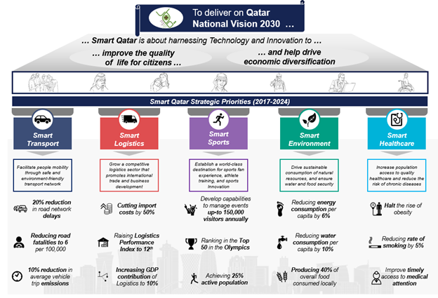
Figure 1: TASMU Key Objectives

Delivering on the mandate of Smart Qatar requires digital transformation across the national priority sectors, and the implementation and deployment of Smart Services that build on the applications of the latest technologies to the challenges faced by the citizens, residents, and visitors of Qatar.

TASMU PROGRAM GOVERNANCE

The governance model for TASMU has been designed to align planning, co-ordination and execution of all activities relating to TASMU across national stakeholders.
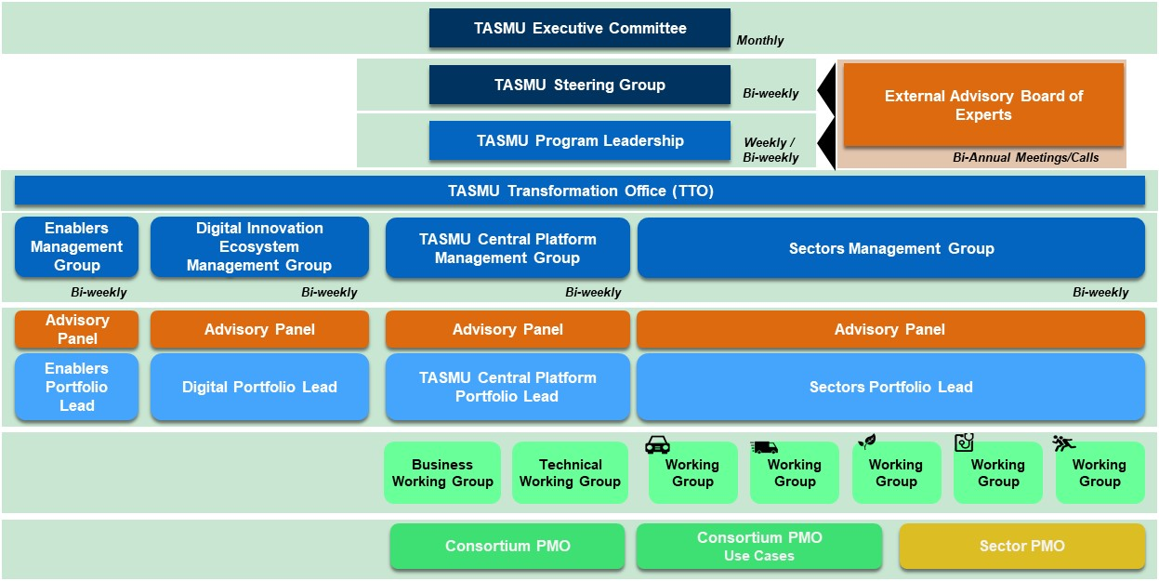
Figure 2: TASMU Governance Model

The TASMU program acts as the authority responsible for oversight and support across financial and operational processes throughout the project. The TASMU program together with the General Authority of Customs, are responsible for approval of project deliverables.
Please refer Appendix 1 – TASMU Governance Overview which provides an overview of the role and responsibilities of each of the committee and groups within TASMU governance.
The TASMU Transformation Office owns the TASMU strategy and represents the strategic program management office. The TASMU Transformation Office manages the relationship with the TASMU Executive Committee that represents the decision-making authority for the Program and includes leadership across the sectors.

POLICIES AND STANDARDS
The Smart Sector Smart Services Implementation should comply with latest versions of relevant national policies and standards to ensure national security, resilience, and interoperability. These would include, but are not limited to:
- Personal Data Protection Law
- Critical Information Infrastructure Protection (CIIP) Law
- National Information Assurance Policy (NIA)
- Open Data Policy
- Cloud Security Policy
- National Industrial Control Systems (ICS) Security Standard
- Smart Qatar Platform IT Architecture Standards (provided in the Appendix)
- Smart Qatar Data Standards (provided in the Appendix)
- Smart Qatar Information Security Standards (provided in the Appendix)
- Qatar’s e-Accessibility Policy
- Electronic Commerce and Transactions Law
- Qatar E-Commerce Guidelines
- Government Web/eService Guidelines
- E-Wallet Regulations
- Security Policy (TASMU-SEC-POL, 001/2020)
- Data Policy– Draft Stage
- Interoperability Policy (TASMU-INT-POL, 003/2020) – Draft Stage
- Societal Impact policy– Draft Stage
- TASMU Experience Policy (TASMU-EXP-POL, 005/2020) – Draft Stage
- Market & Competition Policy – Yet to be drafted

PROJECT OVERVIEW

DIGITAL AUCTION MARKETPLACE
The Digital Auction Marketplace use case consists of developing an auctioning automation system that facilitates purchasing of unclaimed port merchandise through an online portal and a mobile application covering the entire auctioning process.
Unclaimed items at ports lead to additional costs related to processing and warehousing. Also, the current auctioning procedures have limited reach, covering the items’ storage duration under port responsibility. These items end up being disposed of with limited benefit for the port authority.
It is important to note that the Digital Auction Marketplace helps streamline the auction process by reducing operational costs of warehousing and potential wastage of lost and found merchandise.

PROJECT GOVERNANCE
Project governance refers to the model highlighting different project stakeholders, their roles and responsibilities, and the interaction between them.
The key stakeholders team members for each governing body would be defined according to the following illustrative structure in the figure below:
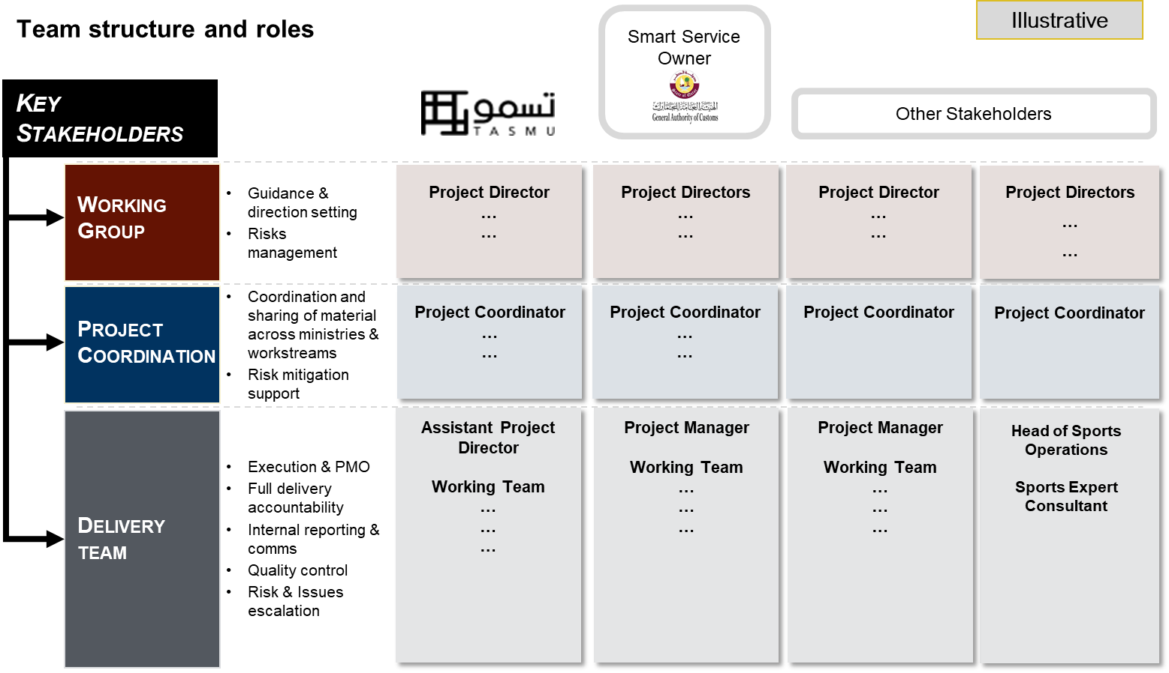
Figure 3: Team Structure and Roles
The key stakeholders are defined as follows:
Smart Service Owner (General Authority of Customs Online Auctioning Team)
The Smart Service Owner is responsible for owning and operating the project after handover from the Service Provider. The Smart Service Owner will work closely with the Service Provider throughout the project phases leading to project handover. The Smart Service Owner is the entity approving project deliverables in coordination with the TASMU Program.
TASMU
Working together with the Smart Service Owner, The Service Provider would report on the project status to the Smart Sector Program Management Office (Sector PMO) that would in turn report to the TASMU Transformation Office (TTO).
Other Relevant Stakeholders
Other Relevant Stakeholders are external stakeholders that are directly or indirectly involved and influenced by the provision of the Services. Such stakeholders are usually consulted and occasionally provide approval and/or support on certain proposed courses of action. The Service Provider is expected to engage the priority sectors’ ecosystems of public and private entities as required for the Smart Service implementation (e.g. Supreme Committee, QOC, etc.).

LEGAL

SERVICES
The general nature of the Services to be rendered by the Service Provider is set out in Chapter 3 (Statement of Work), Chapter 4 (General Requirements), and Chapter 5 (Project Management Requirements) of this RFP. Bidders are invited to refine and/or supplement the contents of Chapter 3 and 4 within the guidelines set out in this RFP and are required to submit, as part of their Proposal, a proposed definitive Scope of Work for the Services which will form Schedule 1 of the Agreement to be entered into between MOTC and the Successful Bidder. Upon finalization of the tendering process, the awarded successful Bidder shall be referred to as the Vendor.

LAWS AND REGULATIONS
The Bidder and the Service Provider shall comply with the laws of the State of Qatar at all times. The Bidder shall make itself fully aware of, and shall account within its Proposal the impact of, compliance with all such laws. The Agreement shall be governed by and construed in accordance with the laws of the State of Qatar.

PERMITS AND LICENSES
The Service Provider shall be responsible for applying for and obtaining all permits and licenses necessary to provide the Services under the Agreement. The Bidder shall satisfy itself as to the procedures and timeframes required for such consents and licenses. It is emphasized that the responsibility for identifying and obtaining the consents and licenses rests solely with the Bidder and the Service Provider.

DISCLAIMER
The information presented in this RFP is furnished solely for the purpose of assisting prospective Bidders in making their own evaluation of the Project and does not purport to be all-inclusive or to contain all the information that prospective Bidders may require. Prospective Bidders should make their own investigations, projections and conclusions and consult their own advisers to verify independently the information contained in this RFP, and to obtain any additional information that they may require, prior to submitting a Proposal. No member of MOTC nor any of their respective advisors and consultants make any representation or warranty as to the completeness of this RFP nor have they any liability for any representations (express or implied) contained in, or omitted from, this RFP.

BUSINESS OBJECTIVES

BACKGROUND
Today, GAC’s current auctioning procedures have limited reach, covering items’ storage duration under port responsibility. These unclaimed items at ports lead to additional costs related to processing and warehousing and end up being disposed of with limited benefit for the port authority.
For that reason, there is a need to establish an auctioning automation system, focusing on 2 main areas: driving sales with marketing, coupled with process digitization and workflow automation to support the different departments within GAC in managing the auction process.
This is where TASMU comes in with its digital expertise to support the GAC Online Auctioning Team in designing and developing a solution to respond to the identified needs. This is a solid foundation upon which the GAC Online Auctioning Team can develop further digital initiatives to monitor and gain insights into Auction's activities.

BENEFITS & OUTCOME

SMART OBJECTIVES
The Smart Service will help achieve the below objectives:
- Cutting import costs by 50%
- Raising Logistics Performance Index to 12th

KEY EXPECTED BENEFITS
The Smart Service is expected to yield the below benefits:
Drive sales with marketing to have a consistent automated end-to-end sales process by capturing the full 'Auction to Final Selling' process through a centralized application allowing GAC to:
- Achieve the vision of the General Authority of Customs in digital transformation
- Expand the participation base in Customs auctions
- Promote auctions integrity and transparency
- Speed up auctioning qualification through managed workflow & approval steps
- Improve efficiency by eliminating duplicated work updating various systems
- Streamline auctioning through an automated digital process
- Improve Customs team performance and empower with digital tools
- Enable insight-driven action through increased access to dashboards and reports
And further expected benefits such as:
- Improve customer experience
- Improve financial returns on events
- Provide shared views and updates across GAC departments
- Adopt international best practices in terms of capabilities & processes
- Enable lead to cash process

PROJECT KEY PERFORMANCE IINDICATORS / KEY MILESTONES
Project Management Indicators
- Percentage completion
- Number of issues not identified as risks
- Milestones achieved
- Weekly reporting completed
- Monthly reporting completed

Solution Indicators
- Number of registered users
- Number of viewers per auction
- Number of users participating in auctions
- Number of successful auctions

Expected values to be defined during the Discovery phase

STATEMENT OF WORK

PROJECT SCOPE
The following sections detail out the scope of work required from the bidder.
The Bidder should submit a detailed point by point response statement to this section. The proposed system should comply and accomplish the stated Services below.
The motivation for the Digital Auction Marketplace use case stems from the key objectives to accelerate unclaimed items disposal and minimize associated warehousing costs. To achieve that, GAC’s auctions need to reach a wider audience by driving sales with marketing while leveraging consistent automated end to end sales processes enriched with Events Management capabilities to improve customer experience.
The Smart Service Owner is looking to build an automated auctioning system that includes a Web Portal and Mobile Application for:
- Auction Bidders / Users for registration and participation in auctions
- A Backend system for auction process management that includes:
  - Approval workflows for each department at GAC (e.g. Legal, Finance, Procurement, Customs, and Inventory, etc.)
  - Auction item management system
  - Dashboards and Reporting
  - Deposit and Payment Capabilities
  - Etc.
Also, the solution should seamlessly connect the concerned parties, providing Citizens, Expatriates, and GAC employees with a modern and innovative portal that allows concerned stakeholders to securely execute the auctioning process online with complete transparency, through centralized electronic platform and data which would positively reflect on process productivity and efficiency.
The proposed solution should allow GAC staff to manage items to be entered to the portal and be ready for auctioning process until items are won and given to the bid winner. The portal role will stop on ending the auction on the items level and accordingly managing the item status and notification in the backend. The portal will be built for the sake of auctioning automation until items ownership transfer.
GAC staff represented from diverse departments like Legal, Finance, Procurement, Customs, and Inventory will each engage in the process depending on business requirements and predefined roles. The portal will facilitate to GAC users the basic features related to managing the auction process and items, auctioneers, and profiles.
The proposed solution should comply with the public auction laws of the General Authority of Customs, and State of Qatar.
The proposed solution will be hosted on Azure Qatar. The proposed solution should integrate with the Sector Platform or the Central Platform – depending on availability – to use the services offered by the platform.
The Bidder should consider the below functional and non-functional requirements as a basic set of features, as they are expected to go beyond the proposed list and differentiate their proposal by suggesting innovative additions. The Bidder is requested to suggest separately new features and functionalities that can add value to the system and serve the overarching objectives of TASMU that might not be explicitly described in this RFP; these will be considered in the evaluation.
The Bidder should also provide detailed technical information about the proposed solution, as well as the infrastructure requirements needed to successfully deploy the application and third-party software needed to support the application.

FUNCTIONAL REQUIREMENTS
The Bidder should not consider this list of requirements as final as the Smart Service may require additional functionalities, to be determined in the discovery phase:

AUCTION – BUSINESS PROCESS
Workflow engine must allow staff to manage the biddings starting from the initiation of the bid till the awarding/selling stage.
Workflow engine must allow review, add, and manage the goods during the auctions process dynamically and efficiently. Customs staff have the ability to prepare the contracts, state the item status, announce the time and place for the auction and manage the bidding process through the platform.
The platform should allow for the digital transformation of business processes. Below is the high-level required process. Further details will be shared during the Discovery Phase (e.g., fields, escalations, roles, steps, etc.)
Note: it's essential here to mention that the below process is the only core process of implementing the portal. The below process will be refined, specified and detailed throughout the Discovery, Pilot and Development Phases.
- Collect the Goods/Items details from GAC Customs Warehouse Management System CWMS or manually create them.
- Define Auctioning details from the Auction backend system by providing the location of Goods/Items in addition to other related attributes like duration, start date, end date of bid, etc.
- Once the Auction is approved from involved departments, auction Goods/Items defined in the contract will be published to the portal and Auction Bidders will be notified.
- Define item's review/inspection date, if any.
- Registered Auction Bidders will start bidding on published Goods/Items after settling the Auction deposit.
- Once bidding is over, two highest Registered Auction Bidders will be selected as potential winners noting that the priority is for the first highest Auction Bidder and will be announced as 1st winner.
- Automatically the deposit will be reserved from the 1st winner.
- In case of confirmation and acceptance from the 1st winner, bid will be closed after having paid full amount
- In case of disagreement, 10% deposit will be taken from the 1st winner, whereas the 2nd winner will be automatically notified of possibility having the item
- In case of confirmation from 2nd winner and payment success, the bid will be closed
- In case of disagreement with the 2nd winner, the Auction will be closed or reinitiated from the beginning.
- if a winner is identified, Goods/Items collection date is defined
Note: Auction Bidders will be provided with all legal terms and conditions for participating in auctioning and in case of winning.

OVERALL REQUIREMENTS
- Proposed Solution will be a Web and a Mobile Application.
  - Web application: will be used by both internal and external users. must be responsive and support all channels: web browsers (Google Chrome, Internet Explorer, Safari, etc.) and can be accessed from mobiles devices and tablets.
  - Mobile application: only for external users (Auction Bidders) for both Android and iOS.
- Online registration for Auction Bidders through the National Authentication System NAS shared services
- Integration with GAC Customs Warehouse Management System CWMS to collect Goods/Items released for auctioning with the ability to manually update item details.
- Ability to manually create Goods/Items to be released for auctioning
- Online bidding and auctioning processes
- Online deposit method for bidders to participate in Auctions.
- Multiple payment methods (e.g., e-Payment, bank transfer, etc.) for awarded bidder to pay the final bidding amount.
- Integration services as specified in this RFP (Section 3.1.1 6 – Integrations)
- Automation of all internal processes related to Auctions
- Ability to hold multi auctioning events, track attendance, automate registration, personalize invitations, and auto generate invites.

USERS: ROLES AND MODULES (ONLINE PORTAL AND TECHNOLOGY BACKEND)
The journey of the Auction Bidder in the Proposed Solution should start from Auction Bidders Portal. Parties can register through the portal.
Note: Detailed description of users and roles to be defined in the Discovery Phase.
Auction Bidders Online Portal

Following is an example of Auction Bidders Online Portal functionalities:
- Auction Bidders can access and navigate through the Online Portal without registration
- Only registered and approved Auction Bidders should be able participate in auctions once the bidding starts.
- Auction Bidders should agree on Terms and Conditions once registered.
- Registered Auction Bidders should be able to create profiles. Following is an example of the required information for Auction Bidders to register:
  - Full Name
  - QID
  - Email
  - Mobile Number
  - Nationality
  - Payment information
  - Auction Bidder type (company/Personal)
  - If company- CR number, company name, location, contact details
  - Upload documents (e.g., if company, an authority letter, document, or power of attorney, empowering the Auction Bidder to undertake bidding decisions on behalf of the company, and the company declaring that such bids will be honored).
- Auction Bidders should be able to register as individuals or represent one or multiple companies. Also, companies can be represented by multiple individuals.
- The National Authentication System (NAS) is only used during registration by Qatari nationals and citizens. A manual registration should be available for non-Qatari ID holders.
- Registered Auction Bidders should be able to have a unique Auctioning ID generated by the portal to be used throughout the auctioning processes.
- Registered Auction Bidders should be able to participate in auctions only if they are eligible and meet the criteria specified by GAC Auction Administrators. Criteria will be shared during Discovery Phase.
- Registered Auction Bidders should be able to manage their profiles. Following is an example of the required functionalities for Auction Bidders.
  - Login
  - Reset password, forget password
  - Edit and update profile details
  - Configure the payment details
  - Add favorite categories to Wishlist
  - Add auctions to Watchlist for ongoing bids to receive updates.
  - Use sorting and filtering of bids (e.g., Bid Closing Dates, Items Category, Items Brand, Country of Origin, etc.)
  - Manage the bids (Purchased items, Participated in auction, etc.)
  - Review old purchases
- Auction Bidder should be able to access auctions by browsing and searching the Goods/Items
- Registered Auction Bidder should be able to receive automatic bid recommendations.
- Registered Auction Bidders should be able to participate in bidding after settling the Auction deposit. Payment deposit should be released in case the Auction Bidder wasn’t awarded.
- The awarded Registered Auction Bidders should be able to pay the final bidding amount using multiple payment methods (e.g., e-Payment, bank transfer, etc.).
- Registered Auction Bidder should be able to receive SMS, Emails, Mobile App Notifications on new bids, auctions updates, newsletters, scheduled reminders, Wishlist, favorite categories, etc.
- Registered Auction Bidders should be able to connect to Customs Team through a Chat Bot or direct messages for auction related inquiries before the auction is live.
- Registered Auction Bidders should be able to use a calendar to schedule Goods/Items inspection from the Online Platform before the auction is live, based on availabilities specified by the Customs Team.
- Auction Bidder should be able to share Auctions on social media channels (e.g., Facebook, Instagram, Twitter, LinkedIn, etc.)

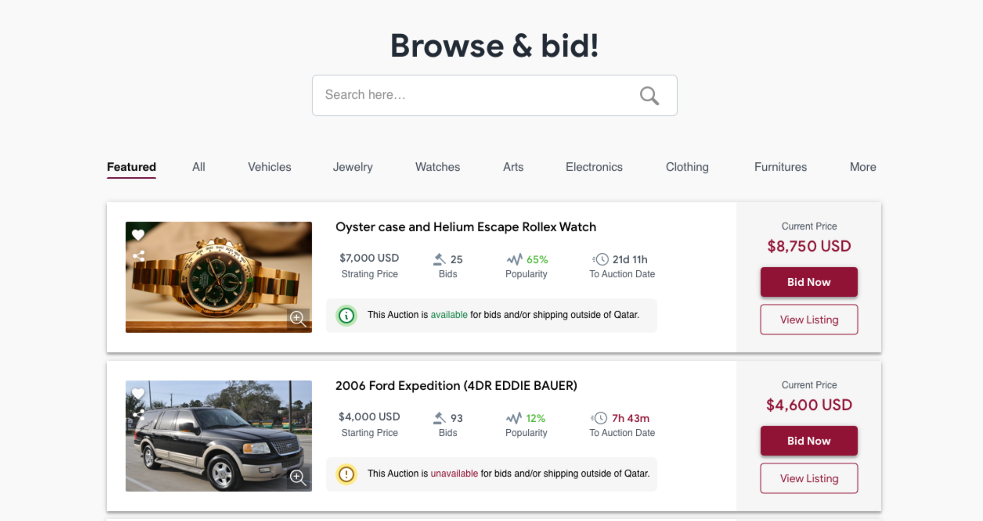
- Auction Bidders should be able to subscribe/unsubscribe to the Digital Auction Marketplace Newsletter without registration.

- Auction Bidders should have access to other informative pages "Privacy, terms and conditions, return agreement". Terms and conditions may include data collection for advertising and analytics purposes.
Auction Management Backend Portal
Following is an example of Auction Management Backend Portal functionalities:
- GAC Users (Master Administrator, Auction Manager, Bid Administrators, etc.) are only allowed to access the Backend Portal through Active Directory (AD) at Customs.
- GAC Master Administrator user role will have full control on the system
- GAC Bid Administrator user role will have access to create, edit or delete bids
- GAC Bid Administrator should be able to manage Auction process from backend Create, Edit and Deactivate Goods/Items to be auctioned.
- GAC Auction Manager should be able to approve GAC Bid Administrators actions as stated in the Auction business process “section 3.1.1.1” (e.g., auctions to be published on the portal, approve on awarding the bid to 2nd winner after disagreement with the 1st bidder, etc.).
- GAC Bid Administrator should have access to historical Auctions information.
- GAC Bid Administrator should be able to edit and update Goods/Items imported from the CWMS.
- GAC Bid Administrator should be able to review, approve/ban and manage online Registered Auction Bidders profile.
- GAC Bid Administrator should be able to specify the eligibility criteria for Registered Auction Bidders to participate in auctions (e.g., certified traders in specific sector like healthcare, shipping agents to export Goods/Items outside the country, Goods/Items to be traded internally, Auction Bidder country of origin, etc.).
- GAC Bid Administrator must provide auction Goods/Items with the following details (full details to be finalized during the Discovery Phase)
  - Image
  - Title
  - Description
  - Bid start date
  - Bid end date
  - Starting bid amount
  - Minimum bid raise value
  - Category - each of the categories may have different rules-sets (e.g., for restricted products like pharma, only licensed bidders may be permitted), or timelines/urgency of disposal (e.g., perishable goods)
  - Goods/Items Condition (Brand New, Like New, Good, Poor, etc.)
  - Etc.
- GAC Bid Administrator should not be able to send or receive URLs/Links, pictures or mobile numbers during discussions with Registered Auction Bidders.
- GAC Bid Administrator should be able to schedule Goods/Items (create Goods/Items and specify date and time for publishing).
- GAC Bid Administrator should only be able to manage Auction Goods/Items prior to Bid start date, unless approved by GAC Auction Manager.
- GAC Bid Administrator should be able to specify the Auction deposit amount (e.g., percentage of the starting price, fixed amount).
- GAC Bid Administrator should be able to specify the minimum bid raise value during the auctioning (e.g., percentage of the starting price, fixed amount).
- GAC Bid Administrator should be able to allow Goods/Items inspection and specify the available date and time for inspection of Goods/Items prior to Bid start date.
- GAC Bid Administrator should be able to book or accept the Auction Bidder booking for inspection of Goods/Items.
- GAC Bid Administrator should be able to support all Auction Bidder inquiries through a support ticketing system / Customer service portal.
- GAC Bid Administrator should be able to make Registered Auction Bidders inquiries public in the Q&A section of the Goods/Items auction prior to Bid start date.
- GAC Bid Administrator clarifications to inquiries, Q&A and Auction details cannot be modified or deleted and should be documented to be used in case of a conflict with the bid winner.
- GAC Bid Administrator should be able to act as Auctioneer during a live auction
- GAC Bid Administrator should be able to encourage bidding by generating predefined or customized notifications publicly to all Registered Auction Bidders.
- GAC Bid Administrator should be able to close the auction in case the 1st winner confirmed and paid the full amount.
- GAC Bid Administrator should be able to specify the full amount payment collection dates once the bid is awarded.
- In case of disagreement with the 1st winner, GAC Bid Administrator should be able to collect the deposit amount and automatically notify the 2nd winner of the bid award.
- In case of confirmation and payment of full amount from 2nd winner, GAC Bid Administrator should be able to close the auction.
- In case of disagreement with the 2nd winner, GAC Bid Administrator should be able to close the auction or reschedule it to be re-published.
- GAC Bid Administrator should also be able to update the Auction status manually (e.g., closed, awaiting full payment, awaiting shipment, shipped, etc.)

NOTIFICATIONS
The Proposed Solution should be equipped with a Notification Engine that allows notification of process and updates to be sent to parties and staff. The notification engine sends out notifications through email and SMS. All notifications are also available on the Customer Portal. The parties can customize their communication preferences in their portal user profiles.
- Relevant automated notification to registered Auction Bidders (e.g., new bids, events, etc.).
- Relevant notifications to Auction bid winners (e.g., bid award, payment reminder, collection date reminder, etc.).
- Option to send custom notifications to Auction Bidders/users or groups by the Administrator.
- Option for the Auction Bidder/user to opt in/opt out for notifications.
- Option to create automatic groups for e.g. All users, new users, users currently bidding, most bidding/active users, etc.
- Option to log all the notifications sent.

REPORTS AND DASHBOARDS
Measuring the performance of the Proposed solution is important, providing real-time analytics, as well as dashboards and reports can shed light on the performance of Customs and its staff. In addition to a better understanding of the registered Auction Bidders preferences and historical bids.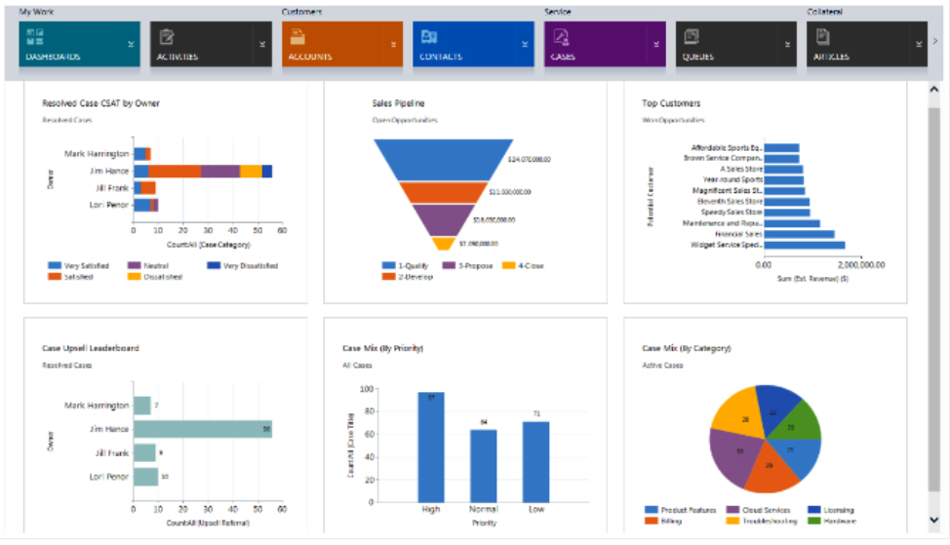
Dashboards to be used to display real-time stats to the users (GAC and Registered Auction Bidders) of the system. The Provided Solution must have dashboards throughout the system for the users of the Portal.
-
The Provided Solution also should provide different reports that can be used to measure key performance indicators. For example,
- Sales report by date
- Number of Auction Bidders by date
- Number of Registered Auction Bidders by bidding history (active Auction Bidders, bid awardees)
- Etc.
The dashboards content and goals will be defined between the Bidder and GAC according to data relevancy and importance to be reviewed from Customs management and teams during the Discovery Phase.
Ability to customize dashboards and report s by adding filter s and sorts based on KPIs.
Ability to export reports to CSV, Excel, and Pdf.

INTEGRATIONS
The Platform must support two-way integration, as needed, with both internal and external systems such as (not limited to):
- National Authentication System (NAS)
- SMS Gateway
- Oracle ERP for online payment
- Customs Warehouse Management System CWMS
- Customs Active Directory
- Maward System
- Alnadeeb
- MoCI Company Registration CR portal
- Network Time Protocol (NTP) service
All other integrations will be clarified during Discovery Phase.

INFRASTRUCTURE AND DEPLOYMENT
The infrastructure and deployment features are listed below:
- The Provided solution should be designed for scalability, high availability, high performance with disaster recovery site
- For any extra needed software component, the Bidder should specify all software licenses with latest versions
- Specify the proper licenses for production, testing, and development environments
- The Provided solution needs to be deployed on 3 environments: Development, Testing and Production environments

OTHER REQUIREMENTS
- The Service Provider should ensure that the developed solution is hosted on Azure Qatar.
- The solution should integrate with the Sector Platform or the Central Platform – depending on availability – to use the services offered by the platform.
- The solution should offer a user friendly and intuitive-to-use interface, purposefully built navigations, menus, and views. The overall look & feel of the interface is an important design parameter to take into consideration.
- The theme should be designed in a formal style that reflects the TASMU and QATAR CUSTOMS branding and white labelling.
- The theme should be applied at all the portal pages and sites including the system and application pages.
- The solution should offer KPI tracking through custom dashboards. The solution should track and report the data required to calculate strategic KPIs linked to this service. Further, automated reports that present the calculated KPIs should be sent on a regular basis to a pre-defined list of people that manage the service.
- The solution should define different types of profiles and offer profile-based privileges to users, i.e. different permissions, features and access to users that are registered, unregistered, verified, unverified, etc.
- The solution should support a dual language functionality (Arabic & English).
- The proposed design should be fully responsive and usable on Desktop, Web (all major browsers), Tablets, Mobile (iOS and Android).
- The platform should provide a guide/walkthrough to help users navigate all features. Different guides will be needed for different types of users
- The Service Provider should align with the Smart Service Owner on all technical terms and expressions to be used across user-facing platforms in both Arabic & English
- The Service Provider should provide the Smart Service Owner with the required roles and corresponding governance for all impacted stakeholders necessary in the management and operation of the Smart Service
- The Service Provider is expected to devise data governance schemes among impacted stakeholders for all required data management functions (including dashboard reporting).
- The solution should be able to interface with existing IT systems of GAC. The solution should have APIs / services that support such interfacing and integration.
- The solution should capture and store data, even when offline.
- The solution shall be designed with Open Industry Standards and not with Service Provider's proprietary protocol.
- All source codes and configuration files related to the solution shall also form part of the project deliverables, which shall be handed over to Smart Service Owner.
- The solution should support two-factor authentication which users can select to enable
- The Smart Service Owner will have the sole ownership of the Intellectual Property Rights (IPR) for the project deliverables.
- The Bidder is expected to provide the Smart Service limitations identified during the Discovery phase and not previously mentioned in the proposal, pending Smart Service owner validation
- The Bidder should provide a clear and comprehensive overview and description on the technology specifications of any proprietary software and hardware (if any) that they intend to use in their proposal. The financial impact, if any, should be accurately reflected in the pricing, described in section 6.

NONFUNCTIONAL REQUIREMENTS

PERFORMANCE
The solution should be designed and implemented considering the performance as one of the key parameters. KPIs should be defined to measure the performance. This includes but is not limited to uptime, availability, error rates, response time, endpoint incidents, and others to be defined by the bidder. Please indicate the tools that can be used for system performance measuring and monitoring.

USABILITY
All applications should be available via a desktop, web interface (supporting all types of browsers), mobile apps (for phone, tablets, and wearables). The quality of usability should be measurable, i.e. how hard is it to use the product? Is it inclusive to all personas?
The Bidder should take into consideration Qatar’s eAccessibility Policy when designing and developing the Smart Service.

SECURITY
The bidder should provide tools to layout required security infrastructure, protect the data and monitor security levels to generate necessary action plans in case of breaches. These measures should take into consideration the policies mentioned in the Policies and Standards section.
For both web and Mobile Application, Vendors should follow all latest security requirements listed below:
- Comply with QCERT, NIA, NCSOC and 2022 roadmap
- Content Security Policy
- Qatar Law for Auctioning.
- Apply the ISO - 27034 standards for Secure system development life cycle in all phases of development, including all required security testing with a complete report as part of deliverables. This will be an essential part of the final acceptance.
- X- Frames options in block mode to prevent clickjacking and other framing attacks
- Anti CSRF cryptographic nonce - building nonce (one-time tokens tied to user sessions) into each form and validating that to ensure that site Customs can't be forced to perform actions.
- DALs data/data base access layers to prevent SOL-injection
- Un-writable file system- making the website code and webserver configuration on the file system un-writable by the web user is a huge security advantage post-compromise
- Forensically secure logging- Logs that are sent off-host or are made otherwise inaccessible by the web user help prevent overwriting the file system, local include at tacks, removing the attacker's tracks from the logs and so on
- Ensure security of credential/ password/ secret questions and answers storage
- SSL- cookies with secure flags
- Security frameworks
- Autocomplete =" off " and strong passwords- To protect Customs site from brute force and from the recent rash of security issues in autocomplete
- 2 Factor authentications for login with SMS OTP feature.
- Audit capabilities, authentications, and group-level security measures
- Levels of security access and permissions, security architecture and secure logins

UPGRADEABILITY
The solution is envisaged to be built on well-established products with clear upgrade plans, and releases with backward compatibility & well-defined migration paths. The implementation will follow the guidelines from products as well as industry best practices to ensure that impact of upgrades is minimal.

INTEROPERABILITY
The bidder is required to report on the efficiency and easiness of integrating the platform data with external systems software and hardware, i.e. the quality of the integration. The bidder should expect to integrate with the Qatar Central Platform functionalities such as payment gateways, authentication services, data warehousing, chatbots, and other related Smart Services if required.
The bidder should be able to implement bi-directional APIs (input/output) to connect with the required third parties, while adhering to data governance policies and standards. This covers integrations with currently used software and processes by the Smart Service Owner

SERVICE LEVEL AGREEMENT
The bidder should provide a well-defined Service Level Agreement (SLA) that fairly guarantees optimum service provisioning for all areas mentioned in the RFP. The bidder should be committed to the proposed SLA targets during the contract period.
Bidder must ensure that the service level management practice helps to set and manage a shared view of the quality of services to service consumer, aimed at all key stakeholders. This applies to both the expected and actual service quality, from initial contact to the present, and covers service offerings and proposed value throughout the entirety of the service relationship. Bidder must ensure that the service level management practice also includes monitoring and evaluation of the actual service quality and continual improvement of the services and its SLA.
The support services shall be of high professional quality confirming to generally accepted industry standards.
The support services shall be provided through Vendor well trained & qualified personnel
The support services can be provided through onsite visits or remote access according to the client's need, time constraints and severity of the issues
The Bidder shall submit with offer the: Support Call Handling Workflow.
The Bidder shall provide in offer the following information: Helpdesk Contacts, Project manager contacts, Escalation Contacts, Management Escalation, Further Escalation & Clarification
Bidder must detail the priority/severity levels and its MTTA , MTTR and status update frequency.
In case of failure in any of the provisioned services, an incident ticket will be raised (in manual or automated way) and will be assigned to the concerned operations team. The ticket will be classified as per the following prioritization
P1 Critical:
  - Production Critical Service completely down and impacting high number of users
  - No single transaction is successfully completed from production critical service
  - The Critical service cannot be provided as no viable or productive workaround is available
  - Indicated the inability to use the program resulting in a critical impact on operations and/or business severely affected
P2 Significant:
  - Incident affecting group of users
  - Production non-Critical Service completely down used by limited number of users
  - Production Service completely down in non-peak hours with limited number of complaints from end users
  - Production Service with poor performance, but the user is still able to use it
  - Repetitive Service disconnection from time to time for short periods
  - Incident affecting the work of the organization’s Senior Management
  - Indicates the program is usable, but severely restricted, and results in an adverse business impact to customer.
P3 Medium:
  - Incident with high impact on individual user
  - Incident affecting non-production services
  - Indicates that the application is usable without some functions that are not critical to the overall operation
  - Degraded performance of the System due to the error with negligible or no business impact to customer
P4 Low:
  - Incident with low impact on individual user
  - Incident with no operational impact
  - Request for assistance or information
  - Indicates that the system is fully functioning with an alternative regime of operation
The following table shows the summary of the targeted SLA:
 | P1 | P2 | P3 | P4
Support Window | 24 x 7 | 16 x 7 | 8 x 7 | 8 x 7
Response Time* Target | Within 30 minutes | Within 1 hour | Within 4 hours | Within 8 hours
Resolution time** target | Within 2 hours | Within 8 hours | Within 2 working days | Within 4 working days

*Response Time: Time from incident logged till the time the support engineer accepted the ticket.
**Resolution Time: Time from the incident logged till the time the support engineer

PROJECT ACTIVITIES
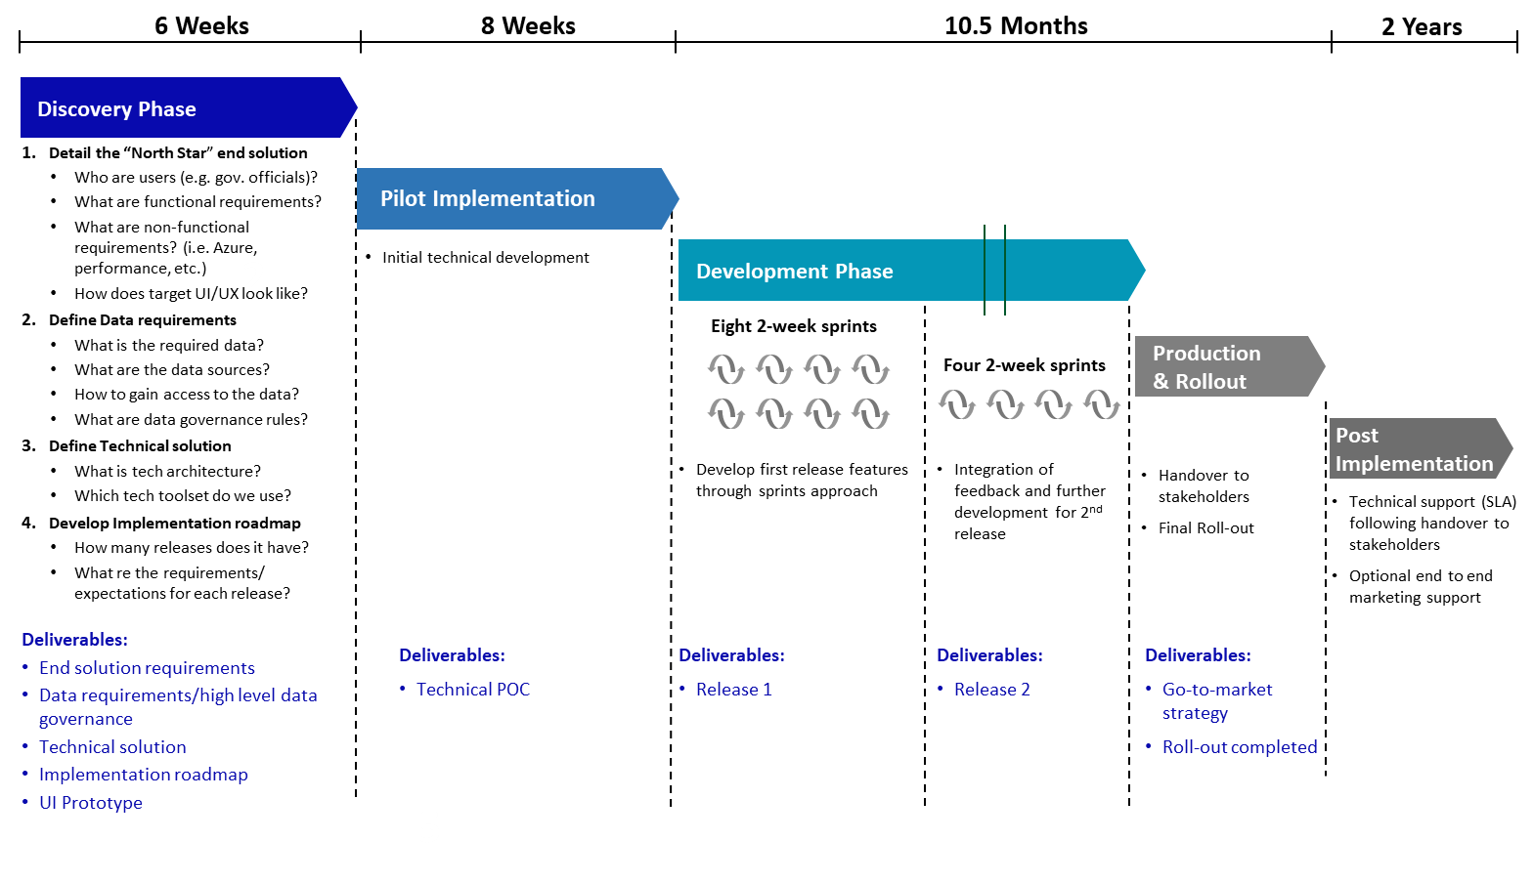
Figure 4: High-level Project Timeline
- The duration for this project is expected to be 14 months (refer to Figure 4):
  - 1.5 months for discovery phase
  - 2 months for pilot implementation
  - 10.5 months for development, production, & roll out
  - 24 months for post implementation phase
- Submit a Project Charter clearly stating the scope of the project, the objectives and stakeholders involved throughout the project phases to be used as a reference document.
- The Service Provider should provide an organizational chart and a resource planning & staffing chart.
- Prepare and present a clear and concise Kickoff deck introducing the project, establishing a common understanding of the project scope and outlining the key activities throughout the project phases starting from Kickoff until Support & Go-to-Market.
- Prepare and provide a comprehensive Project Plan describing all key activities to be accomplished throughout the project phases while adhering to the outlined high-level project phases as highlighted in Section 3.4 (Project Implementation Approach). The project plan should be accompanied by a responsibility assignment section that assigns task responsibilities to different project stakeholders.
- Identify relevant stakeholders for the project. Service Providers should manage all communication relevant to requirements and features with all relevant stakeholders.
- Run a requirement gathering exercise in the Discovery Phase which should include aligning with stakeholders on project objectives, conducting workshops to gather stakeholder input, understanding current systems and data landscape, and reviewing required data sources.
- Develop a data governance model in alignment with the stakeholders. This involves providing data dictionaries, data management approach, data owners mapping and mapping of the data to the Services.
- Review the target user journey with a focus on the visual story boarding, user interactions, and information flows.
- Provide a gap analysis between the current situation and the Services identifying the value added of such Services and implement the required modifications to the Services to maximize its value to the Smart Service Owner.
- Develop the UI/UX materials that are required as part of the development life cycle (e.g. sketches, scenarios, personas, wireframes, high fidelity designs) for a responsive Web and/or mobile apps.
- Conduct a pilot study using pre-defined operational KPIs to examine the feasibility of developing and launching a successful pilot.
- Conduct the pilot based on the criteria agreed on by TASMU and the Smart Service Owner.
- During the pilot, a sandboxing exercise may be undertaken to check if adequate policy / regulatory ecosystem is in place to support the use case implementation.
- Based on outcomes of the pilot, rationalize the results and provide recommendations for pilot scaling in a clearly defined and concise outcome report.
- Compile the Smart Service functional requirements / solution specification report that provides a detailed approach on how the final solution will be implemented.
- Drive the scaling or full implementation of the Smart Service while integrating with identified systems.
- Develop User Acceptance Testing (UAT) scripts and conduct workshops with selected stakeholders to provide training on the Smart Service functionalities and engage in simulation of the journey to capture what went well and the issues faced.
- Based on outcomes of the UAT, rationalize the results and provide recommendations on issues to resolve in a clearly defined and concise outcome report.
- Resolve issues faced during the simulation and launch the Smart Service accordingly.
- Develop training material and prepare capability building workshops for the team responsible for operating the identified Smart Service.
- Onboard different stakeholders on the platform by providing training workshops, managing user registration and ensuring proper usability of the Smart Service.
- Develop and implement strategy for concluding the project, post-implementation project assessment, action planning / follow-up, staffing and operational requirements, and transitioning to the post-implementation environment.
- Develop an adoption strategy that includes specific advertising content and format tailored to culture, age group needs and social groups, early adoption incentives and rewards as part of the sector loyalty program.
- Hand-over solution to the Smart Service Owner through a structured and pre-defined process.
- Provide 2-year technical support as per SLA agreement.

SMART QATAR PLATFORM
The Smart Qatar Platform ensures the availability of technology foundations, key common enabling services, and national data to facilitate the development of Smart Services across priority sectors. The design of the Smart Qatar Platform could take different forms; it could be built as one centralized platform across priority sectors, as multiple platforms for each priority sector or apply a hybrid design which can combine elements of both approaches.
The Smart Qatar Platform aims to achieve 4 key objectives:
- Enable Smart Qatar services: Deploy a modular and flexible platform where Smart Qatar services can proliferate, catering to specific sector service needs and the common needs of cross-sector services.
- Ensure efficient use of Smart Qatar investment: Identify common technology capabilities and consolidate efforts accordingly to avoid duplication of investments and ensure efficient development of Smart Qatar.
- Drive integration and collaboration for Smart Qatar services delivery: Establish a common approach for data collection and service development across sectors to ensure integration and interoperability where needed and promote collaboration for Smart Qatar services delivery.
- Foster economic growth: Drive towards a platform economy that bridges Smart Qatar demand and supply, creates new opportunities for large, medium, and small businesses, and thereby expands economic growth.

SMART QATAR PLATFORM DESIGN CONCEPT
The Smart Qatar Platform design is based on a hybrid or ‘platform of platforms’ concept, balancing the need for centralization of specific capabilities and decentralization of others. For instance, data collection is specific to each service deployed, hence, a decentralized approach is needed to allow ownership of data by the respective service provider within a sector. Moreover, enabling services such as data management and analytics, national authentication, payment gateways, Data API services, and others would be used across sectors, hence, a centralized approach is recommended to avoid their duplication. Similarly, edge infrastructure including edge routers and dedicated connectivity would be used across sectors to collect data from IoT devices, hence, a centralized approach is optimal to ensure one-time investment in this infrastructure.

SMART QATAR PLATFORM ARCHITECTURE
The Smart Qatar ‘platform of platforms’ concept implies there are 2 types of platforms to be built:
- The Sector Platform: providing sector-specific capabilities while leveraging centralized communication and data orchestration layers to collect data from IoT devices and other sources, manage sector master data, develop sector big data and insights, and host sector platform services that would enable the development of Smart Qatar service. The Sector Platform additionally enables full interoperability with other platforms to create a full digital ecosystem.
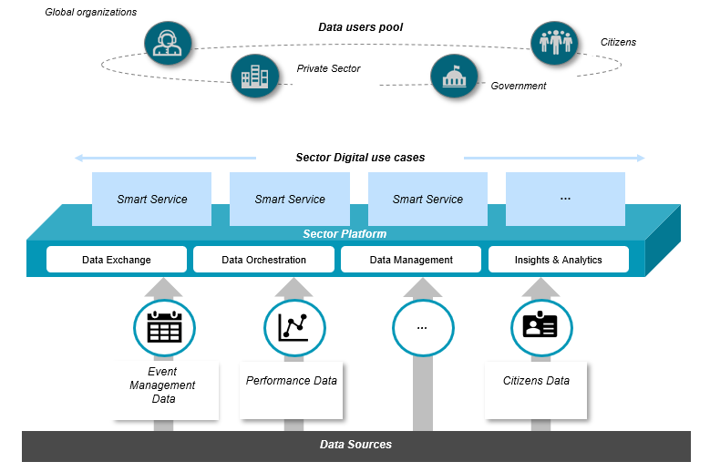

Figure 5: The Smart Qatar Sector Platform Concept

- The Central Platform: providing common capabilities to be leveraged across the various sector platforms including connectivity for IoT devices or edge infrastructure, and common enabling platform services identified as: national authentication, national geospatial services, notification services, Artificial Intelligence and analytics, payment services, open development and testing services, and data API services. The Central Platform also hosts data exposed by the different sectors and provides a shared big data and insights capability.
The Sector Platforms together with the Central layer make up the Smart Qatar Platform and enable Government, local and international businesses, start-ups and their supporting ecosystem, academic and research institutions, as well as the general public to co-create Smart Qatar Services.
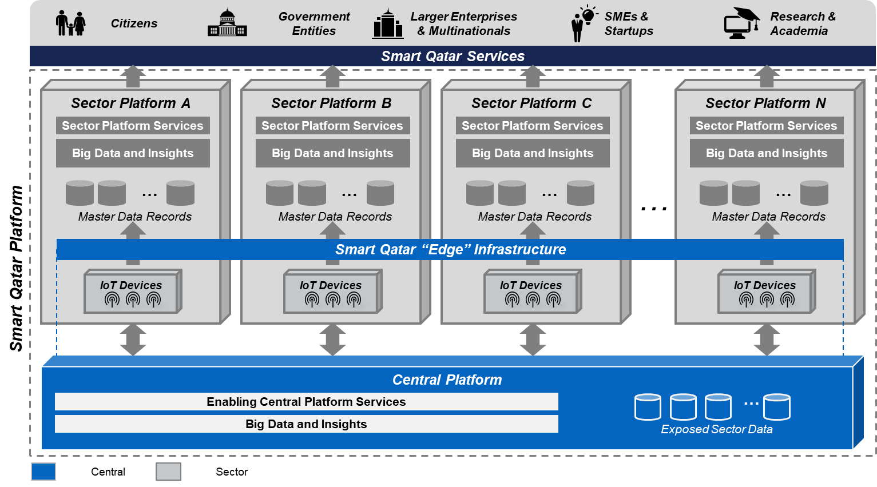
Figure 6: The Smart Qatar Platform - a "Platform of Platforms"
TASMU will share relevant material on the Smart Qatar Platform with the selected Bidder(s) to:
      - Specifically understand which common services (e.g. national authentication, payment gateway, AI & Analytics, others), technology infrastructure, and data will be leveraged from the Smart Qatar Platform without having to replicate them at the Smart Service level.
      - Align on the technical requirements for hosting the smart service on Azure Qatar infrastructure

PROJECT IMPLEMENTATION APPROACH
The Bidder is expected to provide a detailed description of the proposed overall implementation approach. The implementation approach should clearly demonstrate that the Bidder understands how to implement within the TASMU context.
The Bidder should implement a hybrid project management approach, combining aspects of Agile Project Management Methodology with traditional project management methodologies and principles.
The implementation approach should cover the detailed methodology and activities involved throughout all phases of the project since project kick-off until project closing.
The project phases are outlined as follows:
- Kickoff Phase
- Discovery Phase
- Pilot Implementation Phase
- Full Scale Implementation Phase
- Go-to-Market Support Phase
- Post Implementation Support Phase
Project phases are defined as follows:
Kickoff Phase: The kickoff phase represents the activities associated with starting up the project between the Smart Service Owner, the Service Provider and TASMU. The kickoff phase is concluded by the acceptance of the Kickoff presentation during which the Service Provider will present the aligned initial scope, the project team, a high-level project plan and the discovery phase detailed plan.
Discovery Phase: The discovery phase represents the activities associated with getting a well-rounded and in-depth understanding of the goals, scope, data, users, designs (UX/UI) of the Smart Service. During the discovery phase, the requirements of the Smart Service Owner, end-users, and stakeholders are defined through the development of user journeys, an assessment of the current situation and national capabilities in addition to discussions with all relevant stakeholders leading to the proposed outcome document, gap assessment, product backlog and solution designs (UX/UI). This phase helps identify the most optimal features for future product development from both the business and technical perspective and to agree on the detailed designs (UX/UI). Marketing feasibility study should be provided during this phase.
Pilot Implementation Phase: The pilot implementation phase of a project represents the activities associated with developing and implementing a smaller-scale version of the working system. The pilot implementation phase allows the Smart Service Owner and TASMU to check if the solution being developed aligns with the expectations. An unsuccessful project pilot may lead to the termination of the project without further liability to TASMU or the Smart Service Owner.
7The pilot setup and implementation costs should be covered by the bidder as described in Section 6 below.
Full Scale Implementation Phase: The full-scale implementation phase represents the major activities associated with executing the full project scope. The implementation should adhere to the Agile project management tools and processes and leverage backlogs, iterations, sprints and feedback to provide the Smart Service Owner with a higher product quality. During the full-scale implementation phase, the Service Provider conducts user accessibility testing to verify the functionality and validity of the features developed for the service which may be audited by the concerned authority of Govt. of Qatar to ensure adherence to the required compliance. The project is finalized and delivered to the client. The outcome of the full-scale implementation phase is evaluated against the requirements highlighted in the discovery phase. The Service Provider should conduct user accessibility testing to verify the functionality and validity of the features developed for the service which may be audited by the Smart Service Owner to ensure adherence to the required compliances.
Go-to-Market Support Phase:
Go-to-Market:
The go-to-market phase represents the activities associated with developing the overall strategy and designing the operating model of the Smart Service.
The end goal of the go-to-market strategy is to enhance the overall customer experience considering different value proposition aspects. The Service provider’s go-to-market support plan should include a roadmap that measures feasibility and predicts success of the solution based on market research, prior examples, and competitive data. It should include information on product-market fit, target audience’s journey and value matrix, proposed product pricing, competitive analysis, and a proposal of the distribution plan.
Training and knowledge transfer:
During this phase, the Service Provider should develop training manuals and conduct training sessions to onboard the Smart Service Owner and all relevant end-users to the service developed.
Based on the scope, Service provider will follow “Train the Trainer” approach, where the Service provider’s Project Manager will select, in coordination with the ictQatars’ Project Manager, champions to be trained based on the below training types. These champions will themselves train other users, in this way to maintain a smooth and fast knowledge transfer to all the concerned parties. Training will be provided in English and Arabic on-premises.
Service provider to provide Smart Service Owner with a training plan during Full Scale Implementation Phase of the project which will include the different trainings, the number of users per session, the approximate period in the project that the training will be delivered, and any prerequisites which need to be in place.
Service provider will prepare the training material (documentation and use cases), in English as soft copies for end users, administrators and technical users, and Original material for developers.
Service provider will provide separate technical documentation for the coding for front-end and back-end.
Post Implementation Phase:
Technical Support:
The Service provider to provide technical support following project delivery to guarantee the technical health and performance of the solution for a period of 2 years. This includes:
- Providing the support outlined in the support plan
- Delivering the agreed-upon level of support outlined in the SLAs (section 3.1.3), and covering L1 (first line technical support), L2 (advanced technical support) and L3 (development support) support including troubleshooting trainings to the smart service owners [Refer to Appendix 2]
- Providing maintenance support covering corrective, adaptive, perfective and preventive maintenance
- Managing license activation and renewal
In addition to the regular incident-based support, Vendor shall be conducting visits to perform the below tasks before final signoff:
- Conduct monthly an overall health check on the running systems and services.
- Align with the operating teams and respond to any questions related to the products/systems and their functions & operation.
- Provide consultation for possible required improvements & expansions on the current products/systems to meet with growing requirements of the client
- Ensure the products & systems are being optimally utilized by the operating teams
- Provide a report on the status of the operated systems
For the sake of clarity, Technical Support starts after final project delivery.

PROJECT DELIVERABLES
The Bidder should provide a list of planned deliverables throughout the project phases.
All project deliverables should be reviewed and approved by TASMU and the Smart Service Owner.
The first deliverable to be presented by The Bidder is the Project Charter. The Project Charter is a statement of the scope of the project, the objectives, and stakeholders involved throughout the different phases. It provides a preliminary delineation of roles and responsibilities, outlines the project's key goals, and includes the benefits of the project.
All deliverables must be submitted in English & in Arabic Languages at the time of submission. The minimum list of deliverables that should be provided throughout the project phases includes but is not limited to:
Table 1: Key Deliverables per Project Phase
Project Phase | Key Deliverables
Kickoff Phase | - Project Charter  - Kickoff Deck  - Project Plan  - Quality Assurance Plan
Discovery Phase | - Stakeholder Map  - Data Governance / Mapping Model  - Data Integration  - Discovery Report Outcome (Current Assessment)  - Solution Designs (UX/UI)  - Functional Requirements Document (Target State)  - Marketing Feasibility Study  - Pilot Plan  - Service Data Model
Pilot Implementation | - Project Pilot  - Pilot Outcome Report  - Technical Architecture  - Any additional incurred costs should also be covered by the bidder at no additional cost to TASMU or the Smart Service Owner.
Full Scale Implementation | - Sprints Outcomes & Retrospects – number of sprints to be specified by the bidder.  - Plan and Outcome Reports for: User Acceptance Testing, Non-Functional Requirements Testing, and System Integration Testing  - Final Full-Scale Solution (Solution source-code)  - System Documentation (System Design document, System Administration Manual, User Manual)  - System security plan  - Disaster Recovery Plan
Go-to-Market Support Phase | - Training Material and Plan  - Training Outcome Report  - Go-to-market strategy  - Change Management & Handover Plan
Post Implementation | - Ongoing technical support for a minimum period of 2 years following production and roll out according to the support plan and the SLA requirements (refer to section 3.1.3). Technical support should cover L1 (first line technical support), L2 (advanced technical support) and L3 (development support) support including troubleshooting trainings to the smart service owners  - Maintenance support covering corrective, adaptive, perfective and preventive maintenance for a minimum period of 2 years following production and roll out  - Licenses activation and renewal for a minimum period of 2 years following production and roll out

The Bidder should state in the technical proposal in Chapter 9 (Format of Proposals) all detailed deliverables that would be provided throughout the project phases.
Bidder needs to send a compliance sheet confirming their understanding and compliance to the above scope requirements (Appendix 3). As being subject matter experts in this field, Bidder is encouraged to highlight any missing points to that scope.

GENERAL REQUIREMENTS

A successful project depends on certain key success factor that the Bidder must ensure to comply with. The following are identified as general requirements crucial for success of this project:
- All critical phases of the project should be planned, managed and executed with experienced team members on-site.
- Along with the proposal document, Bidder shall submit their business portfolio proving previous (clearly highlighting international, regional and local) experience in subject similar to this project
- Working documents throughout the project shall be submitted in editable format. While updating a document, its versions in track-change format shall be maintained, allowing easy references to feedback provided and relevant document amendments
- Draft deliverables should be shared with the relevant project team members (from MOTC) for feedback and insight, and the final deliverables should be critically reviewed and signed by the Vendor’s experienced senior management before being sent to MOTC.
- A production of two videos in English and Arabic, will be required to demo the use case; and highlight the use case impact on end-users; respectively.
- The bidder may, at its own expense and responsibility, sub-contract one or more third-party sub-contractors that may be a Start-Up or Small and Medium Sized Enterprises (SMEs) as applicable. The appointment of a sub-contractor falling within either or both of the aforementioned categories, will be taken into consideration as a value-added service in the technical evaluation of the Bidder’s proposal .
- The proposed solution will be hosted on Azure Qatar. The proposed solution must integrate with the Sector Platform and/or the Central Platform – depending on availability – to use the government / non-government shared services offered by the platform. This solution must leverage National Authentication Service (NAS) and any other services through TASMU Central Platform to authenticate its users.
- The bidder should highlight their assumption(s), constraint(s), and foreseen risk(s) element(s) in their proposal. Else, the proposal and following contract shall be considered as “all inclusive” as per this RFP and MOTC’s understanding
- The bidder is encouraged to enlist and highlight support required from MOTC at all key phases of the project development and execution phase.
- All client meetings and deliverables of the project should be performed within MOTC’s office hours i.e. Sunday to Thursday between 7am - 2pm Doha Local Time. Any other arrangements shall be discussed and agreed with MOTC.
- All resources should work on ground. Remote activities should not exceed 10% of the total working days unless otherwise agreed with MOTC.
- All deliverables must be submitted in English and in Arabic language at the time of submission, unless otherwise agreed with MOTC.

PROJECT MANAGEMENT REQUIREMENTS

All Bidder teams are required to familiarize themselves with the policies and processes for project management outlined by TASMU Transformation Office (TTO). These policies and processes are documented in the TTO Handbook with an overview provided under this chapter, covering the high level project management requirements. A copy of TTO Handbook will be provided to the successful bidder upon initiation of the project.
The Bidder shall provide a detailed project plan. The proposed solution/service shall include any functional rationale and the technical approach/methodology adopted to track and manage the proposed delivery of service. Methods for managing the planned tasks which include ensuring quality and on-time delivery should be included in the Proposal. An organization chart shall depict the suggested project structure as well as interfaces and liaisons with the TASMU Governance Structure (refer section 1.2.1.2).
The Bidder shall identify any required involvement of MOTC's personnel in multiple phases of the work undertaken in their proposal.
The Bidder should provide full cooperation and assistance with all MOTC assigned staff in successfully delivering this project.
The Bidder will be dealing directly with the Project Management team assigned under TASMU Governance Structure (refer section 1.2.1.2).
In line with the overall program governance structure, project specific governance documentation including a Project Charter, Project Plan, Escalation Matrix, RACI Matrix should be delivered and agreed during the initial phase of the project.
The Bidder should be compliant with Project Management Institute (PMI) standards.
As part of the overall project the Bidder shall establish a project control office that shall perform at least the following:
- Update the master schedule in MS Project or in an agreed format to reflect activity completion and track schedule changes
- Maintain a summarized program schedule of key high-level activities in a suitable graphical form
- Maintain Risk Register and manage risk mitigation plan
- Maintain Issue Register and take issue resolution plan
- Maintain Change Control Register and take timely decisions on change requests
- Maintain Stakeholder engagement plan
- Produce reports including, but not limited to action logs, project status data sheets, project status reports, executive summary reports and project closure report.
- Project will be monitored and reported on a mutually agreed time frame and format.

PROJECT PLAN
For the purposes of responding to this RFP, the Bidder must provide a detailed project plan in MS Project format. The plan must be comprehensive enough in scope and detail to convey the Bidder’s ability to manage and measure this project as specified in this RFP. The detailed project plan will also be used by MOTC to monitor agreed project milestones during project execution.
The project plan should address clear milestones that align to clear exit-points. These exit-points should be mapped to a well-defined evaluation criterion that permit the MOTC QA/QC team for clearly and easily checking the deliverables and project progress which may result into corrective action for project improvement in term of period and content.
The Bidder must stress on work quality and how quality is ensured in all aspects of the project. The Bidder must indicate in his plan how the status and visibility of project progress will be monitored. Bidder must describe their approach to project management during each project phase, as well as managing and coordinating different phases and activities of the project.
MOTC reserves the right to approve or request changes to the Bidder's project plan.

PROJECT ORGANIZATION PLAN
The Bidder shall provide an organization and staffing plan that includes the organization plan for the management and execution of the project. The project organization includes the governance & organizational structure that highlights the relevant project entities and shows key roles, team members and interaction between the different stakeholders.
Project organization plan must include resource planning covering allocating, onboarding and tracking resources throughout project phases.
Interfaces between departments, sections or groups, and between the Bidder and MOTC shall be demonstrated and explained, as well as the practices and procedures that will govern the control and execution of the work by these departments, sections or groups.
The Bidder shall submit staffing or manpower allocation details in accordance with the project plan. Phasing-in of staff at various stages of the project shall be clearly shown, in addition to the amount of office space required during each stage. The Bidder shall include in the proposal the job description of each staff position. Resumes of staff intended to participate in the project are to be submitted along with the proposal. The Bidder must obtain written consent of MOTC when replacing any staff member within project organization plan, prior to thirty (30) days of such replacement during the project execution. MOTC reserves the right to accept or reject any of the Bidder's staff.
Following project kick-off, staffing or manpower details should be submitted in the Resource Tracker created and it must be maintained during the project.

PROJECT ISSUES & RISK MANAGEMENT PLAN
The Bidder shall describe their approach to managing risk and issues on the project. Upon initiation of the project, the processes and procedures used for managing issues and risks should be aligned with TOO Handbook where appropriate.
Following project kick-off, project risks and issues should be monitored and updated by the vendor using the respective Risk Logs and Issue Logs.

PROJECT COMMUNICATIONS MANAGEMENT PLAN
The Bidder must describe how project communications will be managed referring to project status reporting and other communications events.
The Bidder's proposal shall include a communication plan. The communication plan shall outline the types of reports that will be used by the Bidder to report project status. These include but are not limited to:
- Executive summary reports / executive presentations
- Weekly progress reports
- Monthly progress reports
- Risk and issues reports
- Change and variance reports
- End of each phase reports
- Project closure report
The communication plan should also indicate the frequency and content of each report.
Reporting and communication should be done either in English or in Arabic languages, as per the MOTC’s request. All project communications should adhere to TASMU and MOTC CO-Branding and TASMU branding design guidelines, unless otherwise specified.

PROJECT QUALITY MANAGEMENT
All Bidder teams are required to familiarize themselves with the ISO9001:2015 Quality Management Processes, Standards & Requirements established in MOTC and must adhere to the same during the entire project life cycle.
The Bidder shall provide a quality assurance plan to ensure that ALL delivered services / products / systems meet the stated requirements of this RFP.
The Bidder shall ensure that individuals appointed to measure quality (conformance to requirements) report directly to the manager of the project team and have status at least equal to other groups on the project team.
To achieve quality assurance objectives, the Bidder shall include in their proposal a quality assurance plan to include a cost analysis for the life of the proposed system (where applicable), the cost of system acquisition, operation and support (where applicable), and ensure that all systems are delivered, installed, and placed in operation correctly the first time, on or before schedule (where applicable).

PROJECT PERSONNEL
MOTC requires that a full-time Project Manager be assigned to oversee the development and delivery of the entire project. The Project Manager should have a minimum of ten (10) years of experience managing large scale projects as per the subject of this RFP, for accounts similar in scope and complexity to this project. They must also have demonstrated effective oral and written communications skills in Arabic and English.
Team leads and team members to be selected only post approval from the client (MOTC). Bidders team must comply with MOTC regulations policies and procedures. MOTC reserves the right to change any resource given issues of non-performance and/or discipline. In such cases, the bidder is required to have backup profiles ready and a proper efficient and immediate handover is expected to be managed by the bidder’s lead.

SKILLS AND EXPERTISE
MOTC also requires the availability of at least one Logistics Subject Matter Expert as part of the delivery team for the entire duration of the project. Subject Matter Experts should have a minimum of fifteen (15) years of experience in the subject covered by the scope of this RFP, with a minimum of 10+ years working in Logistics projects and a minimum of 5+ years working with government entities. The expert should exhibit practical understanding of best practices in developing similar smart solutions.
Subject Matter Experts should have undertaken projects of similar scope and nature preferably in local markets but also in other geographies, with a clear understanding of the Qatari market. Subject Matter Experts are especially expected to be present throughout multi-stakeholder workshops, other requirement-gathering meetings and upon request. The Bidder is required to clearly highlight the expert(s) in their resource plan along with the corresponding CV(s).

PRICING REQUIREMENTS
A Bidding Firm’s tendered pricing for provision of the Services pursuant to the terms of the RFP must be presented as all-inclusive fee (including all expenses, allowances and management cost etc.) The Bidder’s tendered pricing– total amount in QAR shall be further broken down to separately present the cost of each of the pricing elements per deliverable. The project shall be priced on a fixed fee basis, and no variable (time and material) fee components shall be included in the project fee, unless it has been specifically requested by MOTC part of this RFP.
The bidder must detail the cost categories per key target elements, as outlined earlier in the RFP.
The bidder may amend the tendered cost for its Proposal only with the written consent of MOTC and following its tendering and procurement procedures.
The following table is a guidance for pricing; however, the bidder can propose more detailed pricing model.
Table 2 : Pricing Breakdown
RFP Area | Detailed Items | Price QAR
Discovery | Complete the discovery phase and submit all required deliverables (refer to section 3.5)
Pilot setup and implementation | - Define and implement a pilot to showcase solution features  - An unsuccessful project pilot may lead to the termination of the project without further liability to TASMU or the Smart Service Owner and all payments should be reimbursed to TASMU  - Any additional incurred costs for approval by the smart service owner should also be covered by the bidder at no additional cost to TASMU
UI / UX | Design and develop UI / UX
Internal and external systems integrations | - National Authentication System (NAS)  - SMS Gateway  - Oracle ERP for online payment  - Customs Warehouse Management System CWMS  - Customs Active Directory  - Maward System  - Alnadeeb  - MoCI Company Registration CR portal  - Network Time Protocol (NTP) service  - Data completeness  - Data normalization, aggregation, and cleaning  - Data governance definition and RACI  - Security
Development of modules and associated functionalities | 3 key modules:  - An online portal for auction items management and internal systems integration  - A backend system to manage the auction process with approval workflow for each department at GAC (e.g. Legal, Finance, Procurement, Customs, and Inventory, etc.)  - A mobile application for user registration and participation in auctions  Key Functionalities:  - Approval workflows for each department at GAC  - Auction item management system  - Dashboards and Reporting  - Deposit and Payment Capabilities
Training and handing over | Develop and implement a training plan, handing over plan and an operating manual to ensure users have full understanding of system capabilities
Operations and support | Ongoing technical support for a minimum period of 2 years, following production and roll out (software and hardware) as specified in section 3.5
Operations and support | Maintenance support for a minimum period of 2 years following production and roll out (software and hardware) as specified in section 3.5
Operations and support | Licenses activation and renewal for a minimum period of 2 years following production and roll out  Licensing costs to be provided as a fixed yearly rate for 5 years after production and roll out
Other | Include all other additional costs to be incurred

The bidder may amend the tendered cost for its Proposal only with the written consent of MOTC and following its tendering and procurement procedures.

SELECTION PROCESS

SELECTION CRITERIA
A review and evaluation of Proposals submitted will be the sole basis for the selection of the Bidder judged to be the best qualified to act as the Service Provider. Proposals will be assessed against the evaluation criteria detailed in 7.2 (Evaluation).
MOTC selects the successful bidder in its sole discretion and is not necessarily bound to accept the lowest priced, or any proposal.
Bidders, who do not meet minimum requirements stated in the RFP will be disqualified.

EVALUATION
Upon receipt, MOTC will evaluate only those proposals, that meets the tender submission requirements set.. MOTC may determine, in its sole discretion that in certain cases, any risks/conflicts/litigation/regulatory matters or any deficiency or failure to comply with the requirements of the RFP disqualifies a Bidder’s Proposal from further consideration.
The evaluation will be completed in two stages; Technical and Financial evaluation. Only those bidders that pass the technical evaluation will be considered for financial evaluation.
The total evaluation score will be out of a possible score of 100 (Technical plus Financial). The Technical evaluation will be out of a possible score of 80. The Financial evaluation will be out of a possible score of 20. Minimum passing score per section is as per the following:
Table 3: Minimum Passing Score
Description | Total Score | Minimum passing score
Technical Evaluation | 80 | 48
Financial Evaluation | 20 | 8
Total | 100 | 56
The tender will be awarded to a single bidder, who achieves the highest total score (which is the sum of their respective technical and financial scores) subject to 7.3, and this implies that it is not necessary to award the lowest financial bidder that passes the technical evaluation.
Based upon evaluation scoring, bidders may be invited for individual presentations.
Please note the following:
- Bidder need to meet minimum score for each criteria (1.1, 1.2, 1.3,…, etc.) as well as the minimum passing score for overall evaluation.
- Failing in either the Technical or Financial evaluation will result in the bidder being eliminated from consideration.

EVALUATION CRITERIA – TECHNICAL
Table 4: Criteria and Weights for Evaluation - Technical
ITEM | CRITERIA | Total Score (absolute) | Minimum Passing Score (absolute) | Requirements
1 | Technical Evaluation | 80 | 48
1.1 | Qualifications and experience of the proposed project team | 12 | 6 | Refer to 5.6
1.1.1 | Structure of the team (including on ground and pool of experts) | 3 |  | Clearly defined team structure & governance. Clear definition of roles and responsibilities.  Refer to 5.2
1.1.2 | Qualifications and experience of the project team on the ground  (CV including certifications, specializations, others) across each of the roles proposed by the Bidder | 3 |  | Leads & managers should justify 10 or more years of consulting experience.  All proposed team members should justify relevant experience for their proposed roles.  Project team CVs, Certifications – Refer to 5.6 and 9.1.6
1.1.3 | Prior experience in similar projects | 3 |  | Provide brief about each team member justifying experience in similar projects indicating the name of the client/organization, location, dates, duration and scope of work.  Refer to 5.6 and 9.1.6
1.1.4 | Some of the team members on the ground are expected to be bi-lingual | 1 |  | The bidder must provide at least one bilingual (Arabic & English) team member per each project phase.  Refer to 5.6
1.1.5 | Profile of experts to be engaged | 2 |  | CVs of proposed experts must demonstrate subject matter expertise.  Refer to 5.6 and 9.1.6
1.2 | Company profile | 12 | 6 | Refer to 9.1.5
1.2.1 | Relevant public sector credentials | 2.4 |  | Company profile outlining credentials in public sector.  Refer to 9.1.5
1.2.2 | Track record of experience in the Middle East and other GCC countries | 2.4 |  | A minimum of 5 references for the bidder in the region. Customer references specific to the subject of this project indicating the name of the organization, contact details (name, title, email, phone number), scope of work, contract value, dates & duration.  Refer to 9.1.5
1.2.3 | Track record in implementation of similar national scale program(s) in the government | 2.4 |  | A minimum of 5 references for the bidder in the Public Sector. Customer references specific to the subject of this project indicating the name of the organization, contact details (name, title, email, phone number), scope of work, contract value, dates & duration.  Refer to 9.1.5
1.2.4 | Company presence with relevant experience in the targeted sector | 2.4 |  | Bidder must provide justification of local/GCC/International presence, as well as experience in target sector / Industry.  Full mark for multinational company with experience in target sector / industry.  65% mark for GCC company with experience in target sector / industry.  30% mark for local company with experience in target sector / industry.  0 for none of the above.
1.2.5 | Financial stability | 2.4 |  | Bidder should prove its financial capability to deliver the scope of work.  Bidder should provide past three yearly Financial Statements outlining the financial stability in terms of revenues and profitability over past 3 years.
1.3 | Project plan, approach and methodology | 12 | 6
1.3.1 | Project mobilization and work plan | 2.4 |  | Bidder must submit a clear project staffing plan/resources plan inclusive of manpower allocation details.  Bidder must submit project schedule covering scope, time, resource, quality, risks and issues management.  Work plan should also identify milestones, dependencies, and assumptions.  Refer to 5.1 and 5.2
1.3.2 | Project Deliverables | 6 |  | Bidder must identify a clear list of deliverables in the proposal.  Refer to 3.5
1.3.3 | Project management approach | 3.6 |  | Bidder must provide project management approach that highlights overall approach, phasing, gate passing, methodologies, tools, risks and issues management, and best practices.  Refer to 5, 5.3 & 5.4
1.4 | Bidder presentation structure and quality | 12 | 6
1.4.1 | Coherence of the presentation and the team | 3 |  | Bidder must produce a structured presentation having clearly outlined sections covering different proposal areas.  Alignment of the proposed teams’ credentials with their respective roles.
1.4.2 | Team’s time management (doesn’t exceed allocated time) | 3 |  | Bidder must adhere to the time allocated for the presentation and Q&A.
1.4.3 | Proposal’s coverage complete | 3 |  | Bidder must cover the entire proposal in the presentation, in addition to any agenda communicated for that purpose.
1.4.4 | Presence and availability of members of the core execution team | 3 |  | Bidder must ensure onsite presence of core execution team members.
1.5 | Scope of work | 32 | 24
1.5.1 | Addressing the requirements | 8 |  | Bidder needs to prove that the solution:  •Includes the use of Emerging Technology  •Clearly meets all of the use case functional requirements and non-functional requirements, taking into consideration key assumptions  •Clearly and completely addresses the problem  Bidder to clearly explain the workflow of the solution and to submit a detailed point by point response statement to all requirements.  – Refer to 3.1
1.5.2 | Addressing project timelines and activities | 8 |  | Bidder to address requirements as per the project activities – Refer to 3.2  Bidder must ensure to the project timeline while covering all required activities – Refer to 3.2
1.5.3 | Addressing Smart Qatar Central Platform requirements | 8 |  | Bidder to address the alignment in the technical requirements for hosting & integrating the smart service as referenced in 3.3
1.5.4 | Added Value | 8 |  | Bidder to address the general requirements and go above and beyond the stated requirements e.g. engaging local startups, creating videos, etc. – Refer to 4

EVALUATION CRITERIA – FINANCIAL
Table 5: Criteria and Weights for Evaluation – Financial
ITEM | CRITERIA | Total Score (absolute) | Minimum Passing Score (absolute) | Requirements
2 | Financial Evaluation | 20 | 8
2.1 | Overall Cost Assessment  Score = 15 * (Lowest Price/Bidder Price) | 15 | 5 | Bidder must specify the total cost of the project.
2.2 | Quality & Clarity of Financial Proposal  (structure, cost assessment, breakdowns) | 5 | 3 | Bidder must align the cost with deliverables, services, items and any additional work required to achieve the scope of work – Refer to 6 (pricing requirements)

POST TENDER EVALUATION
Following the qualitative evaluation, MOTC may select some or all the Bidders for individual Proposal presentations and negotiations. Negotiations with next highest ranked bidders will begin if terms cannot be reached with the initially or subsequently preferred bidder or if such bidder amends, modifies or withdraws any particular aspect of its Proposal without the consent of MOTC.

CONTRACT AWARD
If MOTC accepts the preferred Bidder’s Proposal as delivered, or if MOTC and the preferred Bidder reach full agreement on the terms and conditions of the Agreement and the Bidder has delivered two (2) duly executed copies of the Agreement, having initialed each page thereof, then such Bidder may be designated the “Successful Bidder”. MOTC will notify the Successful Bidder by email that its Proposal (as may have been amended by negotiation and agreement of the parties) has been accepted (the “Notification of Award”) and MOTC will proceed to execute such copies of the Agreement as delivered by the Successful Bidder. The date of MOTC execution of the Agreement shall be the “Commencement Date” there under. Upon receipt of the Notification of Award, the Successful Bidder shall immediately proceed with all necessary activities and satisfy all conditions so that no delay occurs and that the requirements of the Project schedule are satisfied.
The Successful Bidder shall be responsible for any costs or expenses incurred by it in the negotiation and execution of the Agreement and in the preparation of originals and copies thereof. MOTC shall not be under any obligation to reimburse the Successful Bidder for any such costs or expenses.
MOTC is not obliged to award all the scope of work mentioned in this RFP and reserves the right to partially award the project.

ADMINISTRATIVE INFORMATION AND REQUIREMENTS

TIMETABLE
All Proposals must be submitted through MOTC e-Tendering Portal https://tender.www.gov.qa no later than 17 October 2021 at 10:00 am, Doha Time (GMT +03:00)
Proposals delivered to a location or through alternative channels other than that specified above will not constitute a receipt. It is the Bidder’s sole responsibility to ensure that Proposals are received by the specified time.
Any extension requests need to be properly justified before it can be considered.

PROPOSAL DELIVERY
The Bidder shall submit both the technical as well as the financial proposal only in soft-copy format through e-Tender via the MOTC e-Tendering Portal https://tender.www.gov.qa. No additional copies are to be submitted, unless specifically requested by the MOTC representative.
All communication regarding new tenders, including inquires and submission of the proposal; is to be made only via the e-Tendering Portal https://tender.www.gov.qa. No additional copies are to be submitted, unless specifically requested by the MOTC representative.

REQUEST FOR INFORMATION AND CONTACTS
All communication from the Bidders concerning this RFP including submission of the proposals is to be made only through MOTC e-Tendering Portal https://tender.www.gov.qa.
Any contact by a Bidder with any MOTC staff member subsequent to issuance of the RFP and before ranking of the Proposals and selection by the MOTC Tender Committee regarding the RFP can be grounds for disqualification.

RESPONSES TO INQUIRIES
MOTC will issue responses to inquiries and any other corrections or amendments it deems necessary, in written addenda issued before the Proposal’s due date. Any response/explanation to a query will be addressed and communicated to all Bidders.
Bidders shall not rely on any statements or explanations other than those made in this RFP or in any addendum to this RFP.
Where there appears to be a conflict between the RFP and any addenda issued, the last addendum issued will prevail.

PRE-BID & PROPOSAL PRESENTATION
MOTC may hold a pre-bid meeting after the tender has been published. The MOTC team shall give a project brief and may address queries raised during this meeting. However, it is to be noted that any such queries will only be considered as informal queries. Refer to Section 8.2 & 8.3 on the appropriate method to submit official queries.
If necessary, MOTC will request Bidder for a formal presentation of their Proposal to the Tender Committee. In such case, MOTC will plan to inform the Bidder via e-Tendering Portal to participate in a Proposal Presentation. The bidders shall be expected to give more explanation and details of technical aspects of the proposal, to clarify his/her understanding of the scope of services, to discuss administrative details of the proposal, and so on.

PRIME VENDOR / SECONDARY VENDORS
If the Bidder (prime vendor) believes that it does not have all the expertise and/or resources for the assignment, it may associate with individual consultants and/or vendors (secondary vendors/subcontractors) and engage them in a consortium, joint venture, or sub-consultancy, as appropriate – this shall be clearly mentioned with all relevant details, including name, address, qualifications of consultants, in the proposal.
In case of any joint venture, the Bidder shall submit an authenticated joint venture agreement which shall not change prior to written approval of MOTC. In case a joint venture is formed, after the award of the contract and before contract signing, the joint venture should establish a local company its main object for the execution of the contract.
Prime bidders may associate with secondary vendors invited for this assignment only with MOTC’s approval. Bidders can associate with only one consortium, joint venture, or sub-consultancy; multiple associations will lead directly to disqualification.

RFP DURATION
The Bidder must clearly state in the Proposal that it is valid for a 120-day period from the date of submission.

DISQUALIFICATION
The Bidder is liable to be disqualified in case of failure to meet the technical and bidding requirements of this RFP or in the following cases:
  - Bidder makes attempt to contact or contacts with any MOTC staff member subsequent to issuance of the RFP and before ranking of the Proposals and selection by the MOTC Tender Committee regarding the RFP.
  - During validity of the bid, or its extended period, if any, the bidder changes its quoted prices
  - The bidders’ bid is conditional and has deviations from the terms and conditions of the RFP
  - Bid is received in incomplete form
  - Bid is not accompanied by all the requisite documents
  - Bid is received after the proposal delivery date
  - Information submitted in technical bid is found to be misrepresented, incorrect or false, accidentally unwittingly or otherwise, at any time during the process of the contract (no matter at what stage) or during the tenure of the contract including the extension period if any
  - Bidder is responding multiple times through different consortiums for example
  - Bidder has not achieved the minimum passing score based on the evaluation criteria defined in Section 7.2 (Evaluation).

FORMAT OF PROPOSALS

GUIDELINES
To ease review and evaluation, it is essential that Proposals are presented with the following information in the following sequence and in English language.

PROJECT DEFINITION AND SCOPE OF WORK
Bidders must provide a statement of understanding of the overall scope of the project and an overall description of the Bidder’s role and responsibilities concisely stating the extent, nature, and schedule of the Services to be provided and including a listing of all deliverables and milestones (the “Scope of Work”).
The Bidder shall clearly highlight any additions or deductions to the Services. Bidders shall take note that the Scope of Work, once agreed with MOTC, shall form part of the Agreement as Schedule 1.

PROJECT PLAN AND METHODOLOGY
Bidders must provide a detailed project plan, including the phases, and planned staffing levels per project phase (e.g., as a percentage of available capacity). The proposed solution shall include any functional rationale and the technical approach/methodology adopted.
An organization chart shall depict the suggested project structure as well as interfaces and liaisons to MOTC’s team, as well as to the main stakeholders.

PROJECT PROPOSAL DELIVERABLES
- Approach in developing and reviewing the project intermediary and final deliverables
- Approach in identifying and reaching out to target audience for workshops
- Approach in collecting data for, developing, reviewing and validating impact analysis reports
- Plan for involving different stakeholder groups
- High-level project management plan including project schedule, risk register with anticipated risks & risk responses and communication plan
- The proposal also should include:
  - Timelines
  - Team composition
  - References of similar work done
  - Costs estimates
Furthermore, Bidders should provide a high-level description of how the requirement will be delivered. Note that the absence of a meaningful description about how the requirement will be delivered will be marked down.

BIDDER’s AUTHORIZED NEGOTIATOR
Provide name, title, address, email, telephone and fax number of the bidder’s authorized negotiator, who has the authority, and shall make binding commitments for the primary vendor and all its secondary vendors (if any) for this proposal.

COMPANY PROFILE
Introduce the firm’s organization using the Company Information Table as shown below and add any additional valuable facts (e.g., parent, age, size, number of customers, offices). Please include an ownership structure and an overview of the firm’s organizational structure with special regard to its footprint in the Middle East.
Table 7: Sample Company Profile Table
Company Name
 |  | Current Year-3 | Current Year-2 | Current Year-1 | YTD Current Year
Number of Employees | Globally
Number of Employees | GCC* Countries
Number of Employees | Qatar
Number of Relevant Projects | Globally
Number of Relevant Projects | GCC* Countries
Number of Relevant Projects | Qatar
Company Revenues | Globally
Company Revenues | GCC* Countries
Company Revenues | Qatar
Relevant Project Revenues | Globally
Relevant Project Revenues | GCC* Countries
Relevant Project Revenues | Qatar
If the Bidder (prime vendor) proposes to associate with subcontractors/consultants (secondary vendors) for the assignment, above information must be provided for each secondary vendor, including, business address, email, telephone & fax numbers, year of establishment (including former names and year established), type of ownership, parent company, proposed project manager with contact details.
Provide a list of customer references specific to the subject of this project indicating the name, organization, contact details, scope of work (objectives, approach, methodology, and results), contract volume, and staffing levels.
Table 8: Sample Client References Table
Company Name
Project Name
Client Information | Name
Client Information | Number of Employees
Client Information | Country
Client Information | Sector (Public/Private)
Client Contact | Name
Client Contact | Phone Number
Client Contact | Email
Project Description | Situation
Project Description | Approach
Project Description | Results
Project Volume | Budget
Project Volume | Person-days
Project Duration | Start Date
Project Duration | End Date
Furthermore, indicate how quality assurance was performed during the project and provide appropriate client reference documents.
If the Bidder (prime vendor) proposes to associate with subcontractors/consultants (secondary vendors) for the assignment, above information must be provided for each secondary vendor.

INFORMATION ABOUT INDIVIDUALS AND ACCESS TO FIRM RESOURCES
Provide the name, title, office location, phone number, and fax number of the individual who will serve as the primary contact for MOTC. Provide relevant credentials and qualifications for the primary person. Describe the project team and provide detailed resumes indicating the participation within the customer references defined above (2-3 pages per primary individual, 1-2 pages for others). Discuss the availability to MOTC of all such personnel.
Note: All or certain services must, at the request of MOTC, be provided within MOTC premises. It is usually expected of the bidder and the team to be located in Qatar during the project duration. All CVs submitted must reflect CVs of consultants to be assigned for this project.
Table 9: Sample Team Members CVs Table
Name
Education
Age
Employment History
Relevant Experience and Expertise

COMPENSATION
The Bidder must detail the compensation to be earned for due performance of the Scope of Work, including a breakdown, according to Chapter 3 as part of the financial proposal. All provisional costs not included in the lump sum price or outside of the base Scope of Work must be indicated separately. Refer to Chapter 6 for the details of the pricing.

OTHER INFORMATION
The Bidder must provide any additional information that the Bidder believes would assist MOTC in evaluating the Proposal. Summarize the reasons that the Bidder is best suited to serve as the Service Provider. Discuss the Bidder’s unique attributes and the individuals assigned to the project. Be specific and relate this discussion to how MOTC will benefit from the involvement of the Bidder (2 pages). Please refrain from adding supplementary company information to the Proposal as the information will be excluded from the evaluation process.
All Proposals must be prepared and submitted in accordance with the instructions provided in this RFP. Each Proposal received will be reviewed to determine if the Proposal is responsive to the submission requirements outlined in the RFP. A responsive Proposal is one that follows RFP requirements, includes all documentation, is submitted in the format outlined in the RFP, is of timely submission, and has appropriate signatures as required on each document. Failure to comply with these requirements may deem the Bidder’s Proposal non-responsive.

CONDITION STATEMENT AND OFFICER’s SIGNATURE
The Proposal must be signed by an officer of the Bidder who is legally authorized to enter into a contractual relationship in the name of the Bidder with MOTC. The following statement shall be repeated in the Bidder’s Proposal and signed by such officer:
“[Bidder] agrees to abide by all conditions of this RFP and certify that all information provided in this Proposal is true and correct, that the undersigned is authorized to sign this Proposal on behalf of {Bidder}, that {Bidder} is in compliance with all requirements of this RFP, and that {Bidder} will immediately notify MOTC if any conflict of interest or litigation event or any other event which would materially affect the Bidder’s ability to perform the Services occurs following selection of {Bidder} as the Service Provider for the Project.”

ESSENTIAL TERMS AND CONDITIONS

MOTC RIGHTS
MOTC may, at its sole and absolute discretion, reject any and all or parts of any or all Proposals; re-advertise this RFP; postpone or cancel at any time this RFP process; or waive any irregularities in the RFP or in the Proposals received as a result of this RFP.

CONFIDENTIALITY OF INFORMATION
Upon award of contract, the selected bidder will enter into a Non-Disclosure Agreement with the MOTC. No part of this assignment can be subcontracted or outsourced without a prior approval from MOTC.

PROPOSAL EXPENSES
All expenses involved with preparing and submitting Proposals to MOTC, or any work performed in connection therewith, shall be borne by the Bidder. No payment will be made for any Proposals received, for any other effort required of or made, or for any expense incurred by the Bidder before commencement of Services, which shall commence upon execution of the Agreement by both the Successful Bidder and MOTC.

TAXES
The bidders are solely responsible for any taxes that will be incurred as a result of this proposal and contract.

FORMAL AGREEMENT
This RFP and the Proposal of the Successful Bidder will constitute the basis of the negotiations for the Agreement. Notwithstanding, MOTC’s right to request modifications and or further negotiations concerning any aspect of the Proposal, the Proposal as submitted (or as may be subsequently amended by agreement of Bidder and MOTC) shall constitute an offer capable of acceptance by MOTC by communication of a Notice of Award, at which point Bidder shall be obliged to deliver executed copies of the Agreement.

GOVERNING LAWS
By submitting a Proposal, the Bidder agrees that the Agreement shall be governed by the laws of the State of Qatar.

SUFFICIENCY OF PROPOSAL
The Bidder is responsible for carefully examining all RFP documents including any and all updates or revisions thereto made or announced by MOTC prior to the deadline for submission of Proposals to ensure that the information provided is adequate and clearly understood and that all RFP documents have been received.
The Bidder shall make its own interpretation of any and all information provided in this RFP and shall obtain and verify all necessary data and information including informing itself with respect to all conditions which might in any way affect the cost or the performance of the Services. No relief or consideration will be given for errors and/or omissions contained in this RFP and neither MOTC nor any other member of MOTC (as defined in the Agreement) nor any of their respective advisors or consultants is responsible for the accuracy or completeness of such information and/or its interpretation by Bidder. In no event whatsoever will any member of the MOTC or any of their respective advisors or consultants be liable to Bidder for any information contained in or omitted from this RFP.
Without prejudice to the above, in the event of an inconsistency discovered by a Bidder (who shall be obliged to notify its discovery immediately to MOTC) or by MOTC in the RFP, MOTC shall be entitled, in its absolute discretion, to resolve such inconsistency and to issue details of such resolution to all Bidders by way of notice in this RFP. Any failure or delay by MOTC to issue such a notice shall not entitle any Bidder to any relief or consideration or create any liability between MOTC and any Bidder.
The failure or neglect of the Bidder to carry out these verifications and investigations shall not absolve the Bidder from any of its obligations under the requirements of this RFP or the Agreement subsequently executed with the Successful Bidder.
No relief or consideration will be given for errors and omissions contained in this RFP. No action of MOTC shall amount to an approval of the contents of the relevant Proposal or acceptance of its suitability for the Project. The Agreement, once executed, shall constitute the entire agreement between MOTC and the Service Provider in relation to the provision of the Services.

COMPLIANCE REQUIREMENTS:
The deliverable(s) produced by the vendor should comply with latest versions of relevant national laws, policies and standards to ensure national security, resilience, and interoperability. These would include, but are not limited to:
- National Information Assurance Policy (NIAP)
- Government Website and e-Services Framework
- Personal Data Protection Law
- Cybercrime Law
- Critical Information Infrastructure Protection (CIIP) Law
- Open Data Policy
- Cloud Security Policy
- National Industrial Control Systems (ICS) Security Standard
- Smart Qatar Platform IT Architecture Standards (provided in the Appendix)
- Smart Qatar Data Standards (provided in the Appendix)
- Smart Qatar Information Security Standards (provided in the Appendix)
- Qatar’s eAccessibility Policy
- Electronic Commerce and Transactions Law
- Qatar E-Commerce Guidelines
- E-Wallet Regulations
- Security Policy (TASMU-SEC-POL, 001/2020)
All Bidders / consortiums bidding for this project shall also ensure compliance with the above policies and standards. Further they will also ensure compliance with the relevant Qatari laws that may be in force at the time of submitting their bids.
Copies of the Policies, Standards and Laws are available on MOTC’s public website. Copies of other policies as applicable will be provided with the RFP on the e-Tendering portal by the Project Manager. Bidders are hereby notified that compliance to these policies and standards and laws shall be part of the evaluation criterion during the bid evaluation phase. Furthermore, the Bidder will be required to submit a compliance certificate (where applicable) as part of the acceptance test during project closure.
MOTC shall have the right to assess and verify the compliance status internally or through a third party auditor within a period of one (1) year starting from the date of project acceptance. The cost of such an assessment shall be borne by MOTC. However, any non-conformance highlighted in the assessment will have to be fixed by the Bidder at no extra cost to MOTC.

APPENDIX

APPENDIX 1 – TASMU GOVERNANCE

Strategic
- TASMU Executive Committee - It is responsible for setting the strategic direction of the overall program and ensuring it achieves the ultimate goal of supporting Qatar National Vision 2030
- TASMU Steering Group - It is responsible of taking strategic decisions for the TASMU Program and monitoring the progress and quality of the initiatives to achieve the desired outcomes.
Advisory (Non-Decision Marking)
- Advisory Board of Experts - The board is responsible of providing a strategic, technical, and operational guidance and advice to TASMU Program leadership on leading global trends and practices.
Operational
- TASMU Program Leadership Group;
- Lead the delivery of the TASMU Smart Qatar Program
- Provide strategic operational decision-making to enable effective planning and delivery of the program
- Serves as the first cross portfolio decision-making gateway in terms of actions needed to address and resolve risk/issues or roadblocks encountered
- TASMU Transformation Office (TTO):

- Strategy and Planning - Lead the strategy and planning of the TASMU Transformation Office by driving the effectiveness of the portfolio’s operations and ensuring alignment of TASMU Smart Qatar Program objectives to national strategies and goals.
- PMO & Governance - Lead the PMO operations of the TASMU Transformation Office ensuring adherence to program governance and standards, efficiency of applied tools and methodologies for successful delivery of program objectives.

- Enablers Management Group - Manage the Enablers Portfolio ensuring alignment of its initiatives to program overall objectives, tracking of progress, review, challenge and recommend approval of deliverables
- Digital Innovation Ecosystem Management Group - Manage the Digital Innovation Ecosystem Portfolio ensuring alignment of its initiatives to program overall objectives, tracking of progress, review, challenge and recommend approval of deliverables
- Platform Management Group - Manage the Platform Portfolio ensuring alignment of its initiatives and work-streams to program overall objectives, tracking of progress, review, challenge and approval of deliverables
- Sectors Management Group - Manage the Sectors and Use Case Portfolio ensuring alignment of its initiatives and use cases to program overall objectives, tracking of progress, review, challenge and approval of deliverables
Tactical
- Enablers Portfolio Lead - Lead the development of the Enablers Portfolio delivery strategy to achieve TASMU Program objectives. Work alongside vendors and stakeholders to drive the planning and execution of the portfolio’s initiatives and projects. Acts as the central TASMU point of contact responsible for stakeholder and portfolio management.
- Digital Innovation Ecosystem Portfolio Lead - Lead the development of the Digital Innovation Ecosystem Portfolio delivery strategy to achieve TASMU Program digital agenda. Work alongside vendors and Digital leaders to drive the planning and execution of the portfolio’s initiatives and projects, acting as the central TASMU point of contact responsible for stakeholder and portfolio management.
- Platform Portfolio Lead - Manage the MOTC/TASMU – Vendor partnership overseeing and guiding consortium planning and delivery activities throughout platform design, build and operate lifecycle. Acts as a senior executive working in conjunction with consortium management and platform development and commercialization teams. Central TASMU point of contact responsible for fulfilment of TASMU’s vision and objectives of the Smart Qatar Platform.
- Sector Portfolio Lead - Lead the development of the Sector and Use Case Portfolio delivery strategy ensuring cross sector alignment to achieve TASMU Program objectives. Work alongside vendors and sector representatives to drive the planning and execution of the portfolio’s initiatives and projects. Acts as the central TASMU point of contact responsible for stakeholder and portfolio management.
Working Groups – Platform
- Platform Business Working Group - Ensure effective coordination and collaboration between internal and external stakeholders related to the business-side of platform development and play major role in deliverables review from business perspective
- Platform Technical Working Group - Ensure effective coordination and collaboration between internal and external parties related to the technical matters of the platform and to facilitate deliverables technical reviews and quality assurance reviews to achieve the desired outcome.

Working Groups – Sectors
- Transport Sector Working Group - Ensure effective coordination and collaboration between internal and external stakeholders to facilitate timely completion of TASMU program initiatives with desired outcomes
- Logistics Sector Working Group - Ensure effective coordination and collaboration between internal and external stakeholders to facilitate timely completion of TASMU program initiatives with desired outcomes
- Environment Sector Working Group - Ensure effective coordination and collaboration between internal and external stakeholders to facilitate timely completion of TASMU program initiatives with desired outcomes
- Healthcare Sector Working Group - Ensure effective coordination and collaboration between internal and external stakeholders to facilitate timely completion of TASMU program initiatives with desired outcomes
- Sports Sector Working Group - Ensure effective coordination and collaboration between internal and external stakeholders to facilitate timely completion of TASMU program initiatives with desired outcomes

PMO Layer
- Consortium PMO - The vendors’ internal PMO responsible for the management and oversight of its selected subcontractors responsible for delivering the various work-streams (Platform Development, Business Operations, Investments, Use Cases). Responsible for coordination of delivery, performance, internal and external communication, compliance, and escalation of risks and issues to relevant stakeholders.
- Sector PMO - Oversee selected vendors for sector strategies and use cases. Ensure alignment across sectors and facilitates sector working groups

APPENDIX 2 – IT SUPPORT
- L1 Support: First line technical support
  - Equipped with support staff who have basic knowledge of product / service and skill to troubleshoot very basic issues / problems
  - Examples of incidents handled: password resets, software installation / reinstallation
  - Incidents not resolved are escalated to L2 support
- L2 Support: Advanced technical support
  - Equipped with support staff with more skills and experience in solving complicated problems vs. L1
  - Examples of incidents handled: incidents that require server back-end access, integration, hardware and software interoperability
  - Incidents not resolved are escalated to L3 support
- L3 Support: Development support
  - Equipped with support staff who are experts in their profession and manage the most complex issues
  - Examples of incidents handled: incidents that require code alterations, solution improvements

APPENDIX 3 – COMPLIANCE SHEET
Declaration of Compliance

Tender Reference : [Tender Reference]
Tender Title : RFP to hire a Service Provider for “Add Name of the RFP”
Tender Issue Date : [Day Month] 2021
The Service Provider by signing the below mentioned declaration, states clearly their full understanding of Ministry Of Transport & Communications (MOTC) Tender document and acceptance to all MOTC Terms and Conditions, scope of work as reflected in MOTC Tender Document and all bulletins issued during the course of tender without deviations.
Declaration
We hereby state clearly our full understanding of MOTC Tender Document and by signing this declaration, we confirm our compliance to MOTC Tender Document.

Authorized Signatory

Name: _______________________ Sign: _______________________

Position: ______________________

Company / Firm: _________________

Date: _________________________ Stamp: ______________________

___________________________________________________________
Note: The above declaration will be a mandatory condition for the technical evaluation. Noncompliance to MOTC Tender document may lead to disqualification of the Technical Bid.

END OF RFP

Mean Time To Acknowledge (MTTA): The average time it takes from when an alert is triggered to when work begins on the issue. This metric is useful for tracking your team’s responsiveness and your alert system’s effectiveness.
Mean Time To Resolve (MTTR): the average time it takes to fully resolve a failure. This includes not only the time spent detecting the failure, diagnosing the problem, and repairing the issue, but also the time spent ensuring that the failure won’t happen again. Mean Time To Recovery or Restore (MTTR): The average time it takes to recover from a product or system failure. This includes the full time of the outage—from the time the system or product fails to the time that it becomes fully operational again.

